Note on Development at Hook Park
- This Note considers the action which Claygate Parish Council should take in connection with the proposed development at Hook Park.
- The site covers 53 acres. It is bounded on the west by the A3, on the north by the A309, on the east by Chessington, and on the south by Clayton Road. It is mainly fields, with trees on the north and east boundaries. To the west and south there is some industrial and commercial development: Chessington Equestrian Centre, commercial warehouses and a scrap metal facility. There are also over 30 mobile homes. It is described by the developers, correctly, as “home to storage and industrial uses … already a semi-developed brown field urban fringe landscape, physically contained by the A3 that provides a fixed, hard and permanent outer boundary that naturally restricts urban sprawl or encroachment into the countryside beyond”.

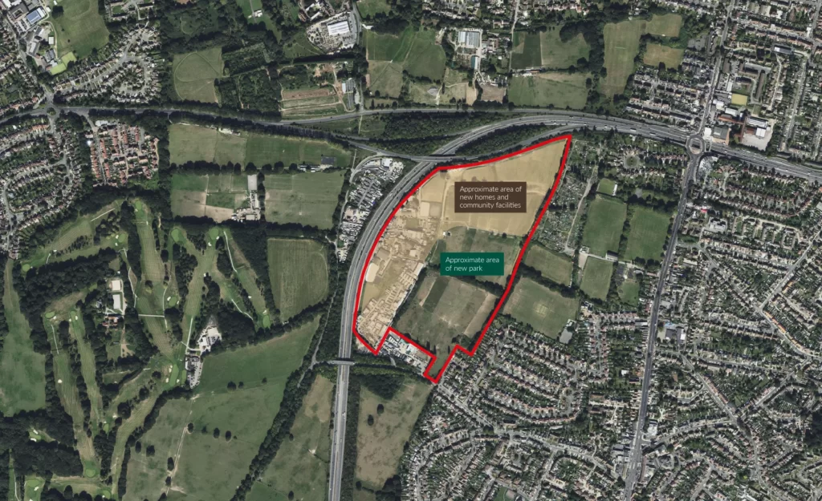

- Before the Esher by-pass part of the A3 was built this was part of Elmbridge Green Belt. When the by-pass was built this site was cut off from the rest of Elmbridge, and therefore made part of the Royal Borough of Kingston-upon-Thames (RBK). It remains part of the Green Belt.
- The 2023 edition of the National Planning Policy Framework (NPPF) says: “Inappropriate development is, by definition, harmful to the Green Belt and should not be approved except in very special circumstances [emphasis supplied]. When considering any planning application, local planning authorities should ensure that substantial weight is given to any harm to the Green Belt. ‘Very special circumstances’ will not exist unless the potential harm to the Green Belt by reason of inappropriateness, and any other harm resulting from the proposal, is clearly outweighed by other considerations. A local planning authority should regard the construction of new buildings as inappropriate in the Green Belt.” A number of exceptions are then listed, none material here. It is this strict interpretation of very special circumstances which resulted in the failure of the appeal on the Land North of Raleigh Drive.
- RBK are even further behind than Elmbridge in formulating their Local Plan. In July 2021 they published a Site Assessments Update “welcoming further thoughts and ideas on the sites that have been submitted to us so far.” They described the site as available for C3 housing, but unsuitable for C3 housing because it was part of the Green Belt. CPC submitted a response saying, inter alia:
“The Parish Council endorses in the strongest possible terms the view that these parcels of land, and indeed all five Green Belt parcels, are unsuitable for C3 housing, or indeed any housing. None of this land should be regarded as available for housing. In the Green Belt Assessment 2018 it was treated as contributing to the Green Belt by preventing urban sprawl, preventing the merger of built up areas, and assisting in safeguarding the countryside from encroachment.
This is particularly the case with [Hook Park]. You will be well aware that developers have ambitions to build between 1,500 and 2,500 dwellings on this site. This is not the place to explain in any detail why building on that scale would have a disastrous effect on existing communities, Claygate in particular. For the present, the Parish Council repeats its often-expressed view that there should be no development at all on any of these parcels of Green Belt land.”
- In January 2023, in the first formal (Regulation 18) consultation on the draft RBK Local Plan, CPC sent a further response reiterating these views.
- The developers have now started their campaign to get the people of Chessington on board. “Our vision will turn this back into a big park for the people, with homes and space for all.” Twenty acres will become a new park accessible to all, while 30 acres “will deliver up to 2000 beautiful new homes built to stand the test of time. 40% of these will be affordable homes. Their design will be traditional mid-rise apartment buildings (known as mansion flats), sensitive to the scale and character of Chessington.
- A mix of 1, 2, 3 and 4 bedrooms
- Meet local demand for all ages, for first-timers, through families, to downsizers
- Larger living spaces and higher ceilings than other modern apartments
- Designed in consultation with local people to fulfil their needs.”
- From the pictures, the “traditional mid-rise apartment buildings (known as mansion flats)” will be 5-storey blocks, and so not unduly “sensitive to the scale and character of Chessington”.
- We can only make a guess at the number of people who might occupy 2000 homes with a mix of 1-4 bedrooms, but it might well be of the order of half the population of Claygate (approx. 7,000). However there is no provision for any infrastructure, schools, shops, doctors, pharmacies etc. There are ambitious proposals for traffic access to the A3 and A309, with a proposal for Clayton Lane to become a roundabout with access to the A3, and to Woodstock Lane in both directions. It is not clear whether the developers would make these changes themselves, or whether they hope Highways England might build the new roads.
- No mention is made of the effect on Claygate of traffic being able to turn South onto Woodstock Lane, not only from the new development, but from the A3 going north. There would inevitably be a large volume of traffic coming into and through Claygate for which we are ill equipped. (There would however be some advantage if Claygate residents were able to turn onto the A3 from Woodstock Lane in both directions, in particular going south without having to use the A244.)
- It was suggested on 6 July that this Note should include a draft letter to RBK urging them yet again not to allow any building on the Green Belt. However on 8 July the Government announced that by the end of August amendments would be made to the NPPF to allow building on some parts of the Green Belt. It is very likely that this would include a relaxation of the very special circumstances test to allow building on areas which, though technically Green Belt, no longer serve the purposes of Green Belt land. The developers will argue – already do argue – that Hook Park does not “prevent unrestricted urban sprawl”, or “prevent neighbouring towns merging into one another”, or “assist in safeguarding the countryside from encroachment” – the three main objects of the Green Belt – since the A3 already does this very effectively.
- When we see the proposed amendments to the NPPF we may have to accept that Hook Park is the sort of “grey” Green Belt land which the Government thinks is suitable for building. I suggest that now is therefore not the time to put forward arguments based on there being no very special circumstances for allowing any building on Hook Park. It may be that we shall have to base our argument to RBK, and to the developers, on 2,000 homes on 30 acres being a gross overdevelopment. For comparison, the land north of Raleigh Drive intended for 60 dwellings (apartment blocks, terraces, semi-detached and larger detached houses, 50% affordable dwellings) is 5.5 acres; at that density, 30 acres could accommodate 325 dwellings, not 2,000.
- I therefore suggest that no action should be taken until after the publication of the amended NPPF, at which point the Planning Committee can again consider what action it should take.

Michael Collon
9 July 2024

