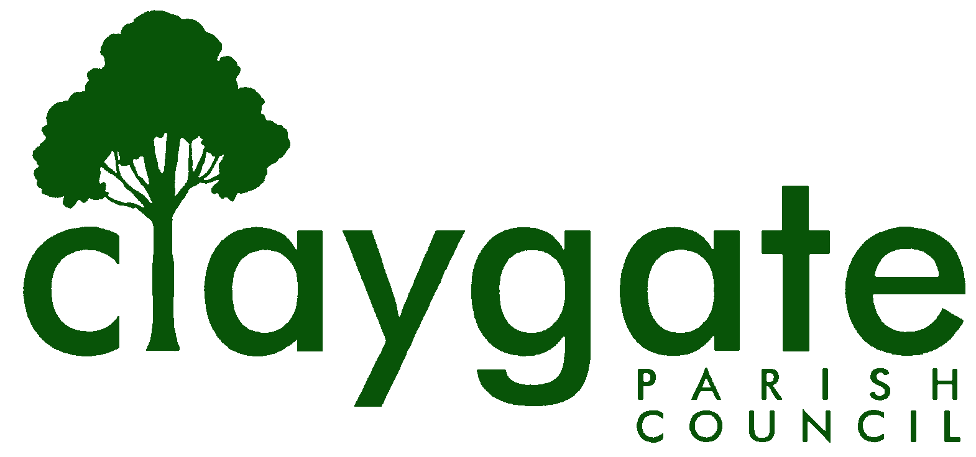

Ron Spurs

Locum Clerk & Responsible Financial Officer

Claygate Parish Council

Claygate Village Hall

Church Road

caring for Claygate Village Claygate

Surrey, KT10 0JP

Tel. No: 07741848719

Email: clerk@claygateparishcouncil.gov.uk

10th July 2023

NOTICE IS HEREBY GIVEN THAT

A meeting of the Planning Committee will be held on Thursday 13th July at 7.30pm at
The Small Village Hall

The meeting is open to the public and press. If attendees have any of the main symptoms of Covid-19 and/or have tested positive to Covid prior to the meeting, you should not attend. Please refer to www.gov.uk for full guidelines.

A quarter of an hour has been reserved for members of the public to address the Council, for three minutes each, on any subject relevant to the agenda. In order to address the meeting, we please request that you contact the Chair of the Parish Council ( sue.grose@claygateparishcouncil.gov.uk ) before 11am on the day of the meeting who will allocate a slot in order of application. All meetings will operate to our Privacy Policy which can be found at www.claygateparishcouncil.gov.uk

AGENDA
- Apologies for absence.
- Declarations of Interest in items on the agenda.
- Confirm the minutes of the 15^{th of} June 2023 Planning Committee meeting.
- Confirm the minutes of the 24th of May 2023 Planning Committee meeting.
- Review actioning of items from previous minutes and agree any further action required.
- Review planning correspondence, notification of applications and outstanding results and agree any action required.
- Review Applications and Appeals decided since last meeting and agree any action required.
- Discuss planning applications from Elmbridge Borough Council (EBC) Weekly Planning Lists (https://www.elmbridge.gov.uk/planning ) for the following weeks and agree responses required: -
w/e 16th June w/e 23rd June, w/e 30th June and w/e 7th July

- Receive a report on EBC’s East Area Sub Committee Meeting and agree any action required.
- Receive a report on EBC’s Planning Committee Meeting and agree any action required.
- Review any Licensing Applications in Claygate and agree any action required.
- Review any Compliance issues in Claygate and agree any action required.
- Discuss any Communication of key decisions to Residents and agree any action required.
- Matters for information purposes only.
- Date of the next meeting 10th August 2023

Website: www.claygateparishcouncil.gov.uk

