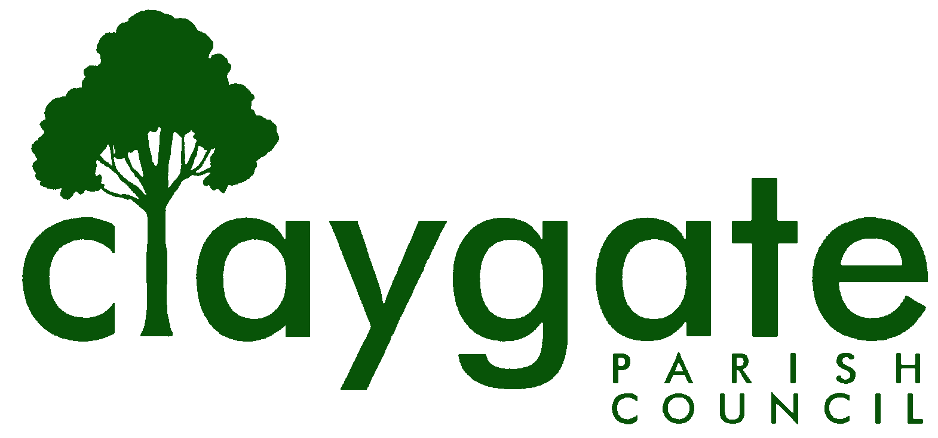
Dawn Lacey – Parish Clerk & RFO

Claygate Parish Council

Claygate Village Hall

Church Road

caring for Claygate Village Claygate

Surrey KT10 0JP

Tel: 07741848719

Email: clerk@claygateparishcouncil.gov.uk
Website: www.claygateparishcouncil.co.uk
FINAL

Minutes of the Main Claygate Parish Council meeting held on Thursday 5th December 2024 at 8.30pm at Claygate Village Hall, Main Hall, Church Road, Claygate

Present: Cllr Holt (Chair), Cllr Sheppard, Cllr Collon, Cllr Herbert, Cllr Moon and Cllr French
In attendance: Dawn Lacey (Parish Clerk & RFO)
6 Members of the Public
1. Apologies for absence.
Apologies from Cllr Bray, Cllr Bingham, Cllr Coffey
The absence of Cllr Freeborn was noted
2. Declarations of Interest in items on the agenda.
None
3. Confirm the minutes of the 7th November 2024 Main Parish Committee meeting.
These were agreed to be a correct copy and were signed and dated by Cllr Holt
4. Review actioning of items from previous minutes and agree any further action required.
Item 9: - to organise a response to the letter from SCCllr Steve Bax – confirmed and agreed – Cllr Bray to write to him
Item 10, Item 11 – both completed
Item 13 – To discuss the movement of monies – taken under Item 19 of this agenda
ACTION – Cllr Holt and Clerk
Item 14 – Completed
Item 15 – To update on the proposed new CPC Website – taken under Item 13 in this agenda
Item 16 – The Vision for Claygate – to send a two page document to the Officers at EBC for their meeting Mid Jan – ACTION Cllr French
Item 18 – To purchase a First Aid Book, Fire Extinguisher and First Aid Kit for our Clean Up Days – this was proposed by Cllr Holt and seconded by Cllr Moon – carried unanimously
ACTION – Clerk to organise the purchase of the above
Item 20 – To update on the new Bench on the Parade – taken under Item 22 in this agenda
5. To answer any questions from the general public
A – This year there were 13 Parish Council meetings and next year there are only 8 scheduled – why was this decision made and why was it not discussed first at a public meeting
The Clerk explained that the timetabling of Meetings are part of her role and she had decided to try and see if we could work with less meetings. It was pointed out that the Chair of the CPC can put in place extra meetings if required.
B – Why, when a question was asked by a member of the public was the reply not recorded in the minutes
The Clerk explained that the missing reply had been from an action from previous minutes which was why it said completed. She will, in future, list the reply in full
C – Did the Parish Council want more members of the public to attend the Green Elmbridge Networking Event? As it only appeared on Social media the day before
This was not a planned public event, but more for specialised people and groups. It wasn’t meant to be over publicised
D – In previous years, the public has been able to see the reconciliations for the past month and the proposed budget for the forthcoming year
The Clerk explained that Appendix 5 was missing from the Website because she didn’t have the Bank Statement in time to complete the Reconciliation. The Clerk did have it available for the Public at the meeting. In future, the Reconciliations will be done 3 monthly at the Main Parish Meetings to avoid this. Regarding the Proposed Budget, which was not, as yet, available because we are still witing for the Tax Base. This will be circulated with the January papers for the January meeting

6. To Receive a Report of EBC’s Overview & Scrutiny Committee & Agree Action As Appropriate
No actions at this time, however Cllr French did inform the Committee that the Car Parking trial is currently taking place in Walton
7. To Receive a Report of EBC’s Audit’s and Standards
No update at this time
8. To confirm the meeting dates for the next two EBC Quarterly meeting:
These were confirmed to be Monday 3rd and Monday 19th May 2025 at 10am
9. To Receive a Report from the Planning Committee
This will be taken under Item 15 on this agenda
10. To Receive a Report from the EH & T Committee
Cllr Holt reported on the following in the absence of Cllr Bray
- Green Elmbridge Networking Event – this was a great success
- Next EHT meeting Dec 12th – report on outcomes etc
- Friday, Nov 29th – Zoom with Niamh Ryan SCC Climate Change Officer
- Dec 10th - SCC Webinar re enabling PC’s to establish Climate & Nature plans
- Greener Futures Group
- Kerb at west end of The Parade – this is bad for wheelchair users. Peter Whitehead raised it initially and I did not do him justice. Idea will be to ask Mark S to get it fixed if approved.

11. To Receive a Report from the Shops and Businesses Advisory Committee
Leo is to organise a survey for the S & B which will remain anonymous and the findings to be reported at a meeting which is scheduled to be held in early February at the Foley Arms in Claygate
12. To Receive a Report from the Health and Wellbeing and Leisure and Advisory Committee
This group haven’t met for some time but Cllr French informed the Committee that the Winning Horse project is still ongoing and they are waiting for funds. Elmbridge were organising a survey on how best to support Vulnerable people.
13. To discuss the way forward for the Claygate Parish Council new Website
There has been some debate on this subject amongst the Councillor’s and a meeting was held to share their views. Cllr Bingham has already put in quite a lot of work for this and it was agreed that the best way forward would be to acquire 3 different quotes from Website organisations: To contact E-Mango, Hugo Fox & Aubergine.
This was proposed by Cllr Holt and Seconded by Cllr Herbert – carried unanimously
ACTION – Cllr Holt and Cllr Bingham
14. To approve the Remit for the Planning Committee
The new remit was approved for adoption and to be added to the Website. Proposed by Cllr Sheppard and seconded by Cllr Moon – carried unanimously.
ACTION – Clerk
15. To discuss the way forward and strategies regarding the EBC’s Local Plan revision
The Committee discussed the evolving situation of the Elmbridge Local Plan against the background of the new Govt housing policy. It was felt that we do not need a new strategy, merely some additional background information and perhaps clarifications of our policies in the light of the changing planning environment. It was agreed that Cllr Sheppard would table a paper to present at our January meeting, by which time the new NPPF should be out. It was also noted that the current plan expires in 2026
16. Weeds in Claygate: To consider the approve Cllr Bray’s draft letter of reply to SCCllr Bax letter of 18/10/24
This was agreed and Proposed by Cllr Sheppard and seconded by Cllr Holt – carried unanimously
17. To Review Presentations made by SCC at the SALC AGM Conference held on Tuesday 19th November and agree any consequent actions
Cllr Sheppard gave a short brief of the event, including information regarding a Greener Future in Surrey and Nature Recovery
18. To Sign off the Reconciliation for November
This was approved and signed by Cllr Holt and the Clerk
19. To move monies from the Main account into the High Interest Account
This was agreed to be discussed with Cllr Holt and the Clerk and to be presented to January meeting as we have now received the Precept payment
ACTION – Cllr Holt and the Clerk
20. To discuss any action to be taken over late payment of the Precept from EBC
This was now N/A as the monies have been received
21. To discuss and approve the Budget and set the precept for 2025/2026
Cllr Holt went through the Budget and explained that we were still waiting for the Tax Base to come through from EBC and until then we were unable to approve this. The Clerk to contact EBC requesting the Tax Base and then to represent the Budget at the January meeting
This was proposed by Cllr Holt and seconded by Cllr Sheppard – carried unanimously
22. To give an update on the new bench for Claygate Parade
It was agreed that the bench would be placed outside the Chemist on the Parade.
This was proposed by Cllr Holt and seconded by Cllr Moon – carried unanimously
Cllr Holt to contact EBC to ask who they use as contractors for this sort of work
ACTION – Cllr Holt
23. To discuss a scenario for the Consultation on Torrington Lodge Car Park which has been suggested
Cllr Holt spoke with the owners of the Chemist while discussing the bench, he is interested in acquiring another larger premises. He asked about the EBC consultation ref Torrington. A suggestion from him was that a chemist could be incorporated into a Health Hub somewhat like Cobham Day Centre. The Doctors surgery were also keen on this idea according to him and asked if he would be interested in representing the parties. This would not be moving the surgery but having day care services from this site. This is something to consider in 2025 during the EBC consultation on Torrington but would need backing from the Integrated Care Board.
24. Matter for Information purposes only
We received a CIL request too late for this meeting as the agenda had already been completed – this will be added to the agenda for the January 2025 meeting
25. To confirm the date and time of the next meeting which will be held on Thursday 9th January at the Treetops Pavillion, Recreation Ground, Church Road, Claygate
The meeting closed at 9.45pm

Signed: Date:

