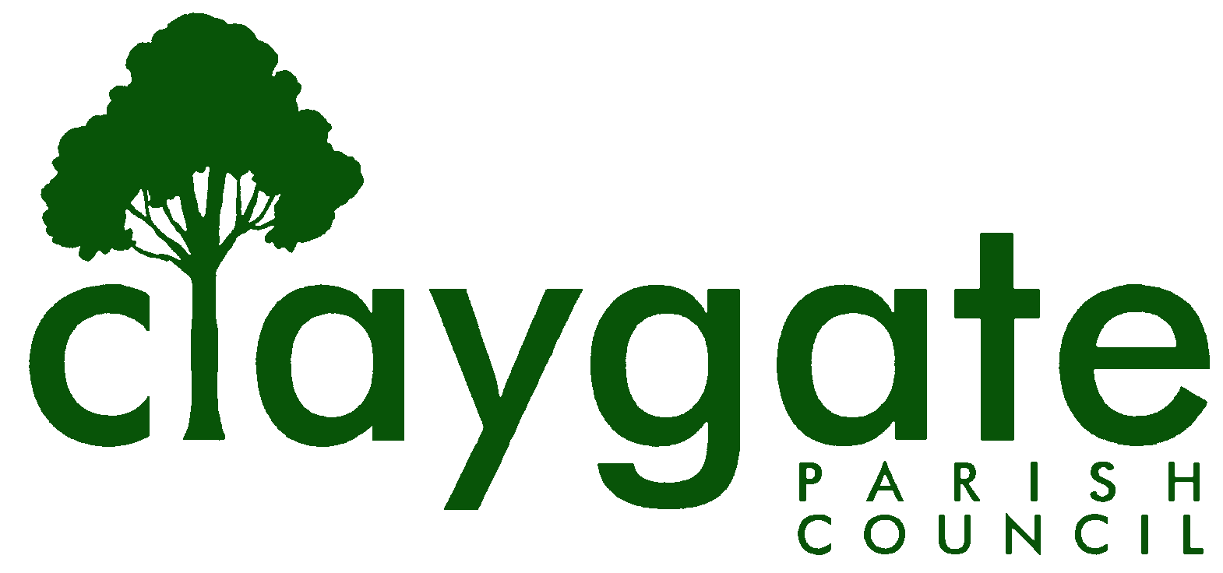
Dawn Lacey – Parish Clerk & RFO

Claygate Parish Council

Claygate Village Hall

Church Road

caring for Claygate Village Claygate

Surrey KT10 0JP

Tel: 07741848719

Email: clerk@claygateparishcouncil.gov.uk
Website: www.claygateparishcouncil.co.uk

FINAL 14th March 2025

Minutes of the Main Claygate Parish Council meeting held on Thursday 27th February 2025 at 8.00pm at Treetops Pavilion, Recreation ground, Church Road, Claygate

Present: Cllr Holt (Chair), Cllr Sheppard, Cllr Herbert, Cllr Coffey, Cllr French, Cllr Bingham, Cllr Bray. Cllr Freeborn joined the meeting at 8.25pm
In attendance: Dawn Lacey (Parish Clerk & RFO)
21 Members of the Public
1. Apologies for absence.
Apologies from Cllr Moon and Cllr Collon
2. Declarations of Interest in items on the agenda.
Cllr Holt declared an interest in 26a and 26b
Cllr French declared an interest in 26b
Cllr Coffey declared an interest in 26b
3. To pass a special resolution on Item 33 for discussion and agree any action required for the Claygate the Way Forward Vision and Action Plan

A special resolution was requested to discuss the Claygate the Way Forward and Action Plan in closed session
This was proposed by Cllr Holt and seconded by Cllr Bray.
Cllr’s Herbert, French and Bingham were in agreement
Cllr Sheppard abstained from Voting
Cllr Freeborn had not yet joined the meeting

4. To move into closed session for Items 31 – 33

This was proposed by Cllr Holt and seconded by Cllr Herbert – carried unanimously
5. To Confirm the minutes of the 5th January 2025 Main Parish Committee meeting.
There were the following amendments:
Item 10 – Cllr Bray has written to Telereal Trilion and not BT estate
Also, Cllr Bray to chase up on a teams meeting with Oscar Akintoye and not Mike Rollings
Item 14 – The new budget was approved (wording updated)
Item 15 – The Councillor’s currently have 3 applications (and not 2) applications for CIL funding to be discussed at the February meeting, where they will look at where the CIL monies can be allocated. It was noted that the condition for CIL Fund award for the Winning Horse project agreed at the Parish Council meeting on 16 May 2024 could not now be met due to the withdrawal of the government’s Community Ownership Fund, so a fresh application by the Claygate Community Benefit Society would be required.
The Minutes with the above amendments were agreed to be a correct copy and were signed and dated by Cllr Holt
Carried unanimously
6. Review actioning of items from previous minutes and agree any further action required.
Item 11 – Completed
Item 14 – Completed
Item 16 – Completed
Item 18 – Completed
Item 19:1 – Ongoing
Item 19:2a – Completed
Item 19:2b - Completed
7. To answer any questions from the general public
None
8. To receive the notes from the Quarterly meeting with EBC
Councillors were in agreement with the minutes of the quarterly meeting circulated by Anne Withers and these are published in the appendices to these minutes for information.

9. To Receive a Report of EBC’s Overview & Scrutiny Committee
Cllr French reported that the Community Centres were under review and would currently continue to operate for 4 days a week
10. To Receive a Report of EBC’s Audit and Standards Committee
Cllr Freeborn reported that the Audit was not yet completed therefore was nothing to report at this time
11. To Receive a Report from the Planning Committee
Nothing to report at this time
12. To Receive a Report from the EH & T Committee
Cllr Bray and other Cllrs met with 7 members of SCC about Local Street Improvement Plan (LSIP). LSIP proposes blanket 20mph across large portions of towns and villages. 70% of CTWF survey respondents in Claygate did not want this type of blanket speed enforcement therefore the CPC view was that LSIP will not be right for Claygate as it would not be approved. Instead, the CPC will work with EBC and SCC to implement specific improvements which are wanted
13. To agree the terms of reference for the CTWF Advisory Committees
A vote of thanks to Cllr French for all her hard work with this was proposed by Cllr Holt and seconded by Cllr Bray – carried unanimously
The terms of reference were agreed.
14. To consider the reappointment of the CTWF Advisory Committee’s and consider if there are any changes to membership
The current members of the CTWF Advisory Committees were appointed. A new Governance Structure is to be produced for publication and is attached as Appendix 1
Proposed by Cllr Bray and seconded by Cllr Sheppard – carried unanimously
ACTION: Clerk
15. To Receive a Report from the Health ,Wellbeing and Leisure Advisory Committee
Cllr French reported that the Committee had met recently and were pursuing opportunities to improve and increase the provision of health services locally. Plans for the provision of an outdoor gym on the Recreation Ground were progressing and a lottery funding bid had been submitted by the Recreation Ground Trust.

16. To Receive a Report from the Shops and Businesses Advisory Committee
Leo Tye reported that the Committee had met and would be moving forward with the Shops and Businesses survey once the Ethics Statement had been approved.
17. To consider a Motion the approval of the Shops and Businesses Advisory Committee’s Survey’s approach and ethics statement
Emma Curtis answered Councillors’ questions about the ethics statement for the survey which was considered for approval. Cllr Bray applauded Emma Curtis for her incredible piece of work
The Motion was Proposed by Cllr Holt and seconded by Cllr Bray – carried unanimously
18. To confirm the Claygate Courier for Production
This was Proposed by Cllr Holt and seconded by Cllr French – carried unanimously
19. To Sign off the Reconciliation for January
The Clerk requested to have this delayed until the next Meeting as the December one will need to be approved again as there are some changes
Proposed by Cllr Holt and seconded by Cllr French – carried unanimously
ACTION – Clerk
20. To confirm the arrangements for the Internal Audit with Simon White
It was agreed that this should take place in April and the Clerk would contact Simon White at EBC
ACTION – Clerk
A discussion was held about having a Process Audit – the Clerk requested that this be deferred until 2025/2026
Proposed by Cllr Holt and seconded by Cllr Bray – carried unanimously
21. To review having a Claygate Recreation Ground Trust Trustee
It was discussed and agreed to not have a CRGT Trustee from the Parish Council at this time. However, Cllr French is happy to continue advising on funding applications as and when required
Proposed by Cllr Holt and seconded by Cllr Herbert – carried unanimously

22. To discuss any arrangements for the Claygate Flower Show
It was confirmed that the next Claygate Flower Show will be held on Saturday 12th July. It was also agreed to have a stand at the event. Clerk to contact the organisers to book a space and table
ACTION - Clerk
23. To confirm the details for the next Claygate Litter Pick
It was confirmed that the next Litter Pick will be held on Saturday 26th April alongside the Claygate Get Involved Day at the Village Hall. Cllr Holt to liaise with Twink Bray regarding the BBQ after the Litter Pick at the Village Hall. The banners needed to be up by 31st March to advertise the event.
ACTION – Cllr Holt to contact Mrs Bray
ACTION – Cllr Moon to have the Banners up by the 31st March
24. To confirm the plans for the Claygate Village Meeting being held on Thursday 20th March at the Claygate Village Hall & to review and confirm the suggested questions for the Meeting regarding Devolution
Cllr Sheppard had circulated a selection of questions for the Panel at the above meeting. These were agreed with one addition to be – Question 2 – How does this affect the CPC?
This was proposed by Cllr Holt and seconded by Cllr Bray – carried unanimously
ACTION – Clerk to send the Questions to the 3 Panellists
25. To consider Grant Applications
A grant application was received from the Claygate Village Association for £187 to cover the costs of the Venue hire for the Claygate Get Involved Day. This was agreed
Proposed by Cllr Bray and seconded by Cllr Sheppard, carried by all other Cllr’s except Cllr Herbert who abstained from voting
ACTION – Clerk to write to CVA to confirm the Grant Offer
26. To consider CIL Grant Applications
Item C – The CIL application for the Claygate Hub was discussed first. Susannah Moffat informed the meeting that they were looking for a £6,000 CIL grant towards helping to pay for the renovations of the sheds at the Hub for the use of the local children
This was proposed by Cllr French and seconded by Cllr Sheppard – carried unanimously
Councillor Holt left the meeting at 8.15pm
In the absence of the Vice-Chair of Council, Cllr Bray, seconded by Cllr French, proposed that Cllr Sheppard should take the chair for this item. This was agreed unanimously.
Item B – The CIL application for Claygate Primary School was discussed. The Head informed the meeting that they were looking for £16,100 CIL grant towards the work needed to work on the field and stop the flooding
This was proposed by Cllr Sheppard and seconded by Cllr Bingham – carried unanimously
Cllrs French and Coffey left the meeting at 8.25pm
Item A – The Way Maker Project at Holy Trinity Church
Rev. Patrick Bateman and a representative of the PCC outlined the revised application for £30,000. Cllr Sheppard indicated that the project was an attractive concept, but the view was that CPC funding should focus on the aspects that improved the accessibility of the churchyard in particular the proposed gate and new path to the Recreation Ground. Cllr Freeborn said he was opposed to the whole project, as being an inappropriate use of a cemetery.
The suitability, and cost, of the proposed material for the new pathway was discussed. Doubt was expressed about the durability of resin bound paving for a public thoroughfare. After discussion, Cllr Sheppard proposed that the grant be limited to the churchyard elements of the proposals, including the gate to the Recreation Ground but excluding the path and the War Memorial Garden, amounting to an award of £9,800. This was seconded by Cllr Bray. The motion was carried with Cllrs Herbert and Bingham in favour and Cllr Freeborn opposed.
Cllr Sheppard commented that this decision would be a disappointment to HTC, but that it would be possible to make a further application for funding for the path, once there was a clearer understanding of the suitability of the proposed material.

ACTION – Clerk to write to all 3 CIL applicants with the offers and confirmations
Cllr Holt, Cllr French and Cllr Coffey re-joined the meeting at 8.45pm
27. To discuss the possibilities of a Claygate Calendar
It was agreed that this was a nice idea but not viable at the moment given everything else that is being progressed with CTWF. To revisit this for 2026
Proposed by Cllr Holt and seconded by Cllr Freeborn – carried unanimously
28. To consider 3 quotes for the Bench on the Parade and select a Contractor
Cllr Holt informed the Committee of the 3 quotes that had been submitted, and the agreed quote was to be with Beadles for £2,290 + VAT
Proposed by Cllr Holt and seconded by Cllr French – carried unanimously
ACTION – Cllr Holt to contact SCC to apply for the licence
ACTION – Clerk to add discussing the wording for Plaque to the next meeting
29. Matters of Information purposes only
a: Community Centres Round Up
This was covered earlier in the meeting
b: Update on the Claygate Parish Council Website
Cllr Bingham has received 4 responses from the 5 agencies she has contacted. Cllr Bingham will share her information and get an idea on what the Councillors are looking to achieve with a new site
ACTION – Cllr Bingham
c: Update on the meeting re the Catchment area for Hinchley Wood School and how and if it will affect Claygate residents
Nothing to report on this currently
d: Update on Free Parking
It was confirmed that there will be 30 minutes free parking at Torrington and Hare Lane Car Parks from 1st April
e: To receive an update on all the various current Consultations
Cllr French had circulated a list of all the various consultations that the Councillors are currently looking at. This is to be added to the Website for Publication
ACTION – Clerk
30. To move into closed session
The Council moved into closed session at 9.45pm
31. To appoint a Winner for the Brian Rhodes Cup
The voting forms were completed by the Councillors and the Clerk announced the Winner which was Susannah Moffat. To send this information to Peter Whitehead after the meeting
ACTION - Clerk
32. To agree the CTWF Vision and Action Plan for Consultation in April by EBC
The CTWF Vision was discussed and approved
Proposed by Cllr French and seconded by Cllr Bray – carried unanimously
The Action Plan was also discussed and approved
Proposed by Cllr Holt and seconded by Cllr Bray – carried unanimously
33. To discuss with the Staffing Committee any updates from the Clerk or from the Council
The Clerk left the meeting whilst this discussion was held and then rejoined the meeting after
34. To confirm the date and time of the next meeting which will be held on Thursday 27th March, Treetops Pavillion, Recreation Ground, Church Road, Claygate
The meeting closed at 10.45pm

Signed: Date:

