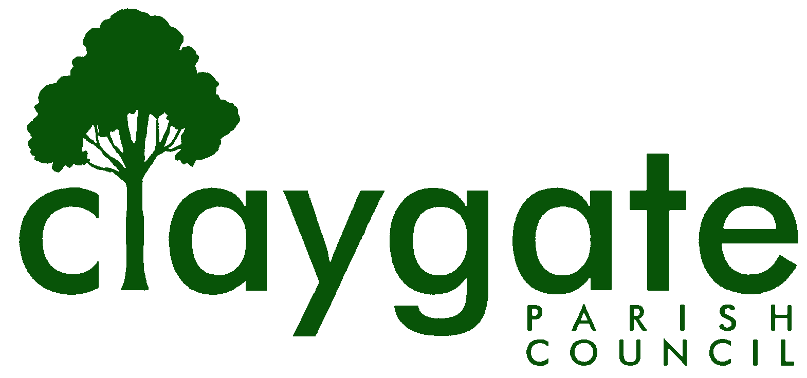

Ron Spurs

Locum Clerk & Responsible Financial Officer

Claygate Parish Council

Claygate Village Hall

Church Road

caring for Claygate Village Claygate

Surrey, KT10 0JP

Tel. No: 07741848719

Email: clerk@claygateparishcouncil.gov.uk

29th June 2023

NOTICE IS HEREBY GIVEN THAT

A Meeting of Claygate Parish Council will be held Thursday 6th July at 7.30pm in the Small Hall at Claygate Village Hall.

The meeting is open to the public and press. If attendees have any of the main symptoms of Covid-19 and/or have tested positive to Covid prior to the meeting you should not attend. Please refer to www.gov.uk for full guidelines. A quarter of an hour has been reserved for members of the public to address the Council, for three minutes each, on any subject relevant to the agenda. In order to address the meeting, we would appreciate you contacting the Parish Clerk before 11am on the day of the meeting who will allocate a slot. All meetings will operate to our Privacy Policy which can be found at www.claygateparishcouncil.gov.uk.

Ron Spurs
Locum Clerk & Responsible Financial Officer

AGENDA

To accept Apologies for Absence.

To receive Declarations of Interest in items on the Agenda.

To confirm the minutes of the Extraordinary meeting held on the 29th June 2023.

To note the minutes of the EBC/CPC Meeting held on the 23rd June 2023.

To confirm the remit of the Parish Council.

To confirm the Charter between CPC and EBC and agree whether to publish on the CPC website.

To review the delegation arrangements to Committees, Employees and other local authorities.

To confirm the terms of reference (Remits) of the Planning, Highways, Transportation and Environment and Staffing Committees and Communications Working Party.

Appoint any non-voting advisors to the Planning Committee.

To review, reaffirm and adopt the Council’s:

Standing orders, Financial Regulations, Members Code, Members Code of Conduct, Health & Safety Policy, Freedom of Information Policy, Freedom of Information, Publication Scheme, Risk Management Policy and Assessment, Document Retention Policy, Data

Protection Policy, Privacy Policy, Dignity at Work Policy, Complaints Procedure, Media &

Communications Policy, CIL Policy and Guidance, Grants Policy and Guidance, Sickness at Work Policy, (See Council Website Policies). Register of Interests and the Hospitality Register. (Attached).

In relation to Communications Working Group proposal see document attached

To consider the introduction of a Councillor Policy Approval tracking document.

To consider the re-signing of the Council to the Civility and Respect Pledge.

To receive a training update on Councillors and discuss any action required.

To make arrangements with a view to the Council becoming eligible to exercise the General power of Competence in the future.

To review and agree the remit, process and responsibility for the Parish Council’s Facebook going forth.

To review and agree the remit, process and responsibility for the Courier going forth.

To consider the payment of an invoice for £12,784.09 inc VAT from Elmbridge Borough Council for the May Elections.

To consider a Climate and Nature grant application from Claygate Scouts for £1000 for Solar Panels.

To consider the erection of a bench to Commemorate the Coronation of King Charles III.

- To consider the need for advertising on a Saturday of free parking at the Station Car park and agree any action required.

- To Debate the Proposed Torrington Road Car Park Development and Agree Appropriate Actions [including a Public Meeting and a Facebook Post).

To receive the report from the Parish Clerk including the actioning of items from previous Council meetings and decide any action arising.

To receive the Finance Report including expenditure for the balance of the year and decide action arising. (The Finance Report will be circulated separately following the month end).

To receive an update from the Planning Committee and agree any action arising.

To receive an update from the Highways, Transportation and Environment Committee and agree any action arising.

To receive an update from the Communications working party and agree any action arising.

Matters for information purposes only.

To confirm that the next meeting of the Claygate Parish Council is to be held on Thursday 21st September at 7.30 pm
Website: www.claygateparishcouncil.gov.uk

