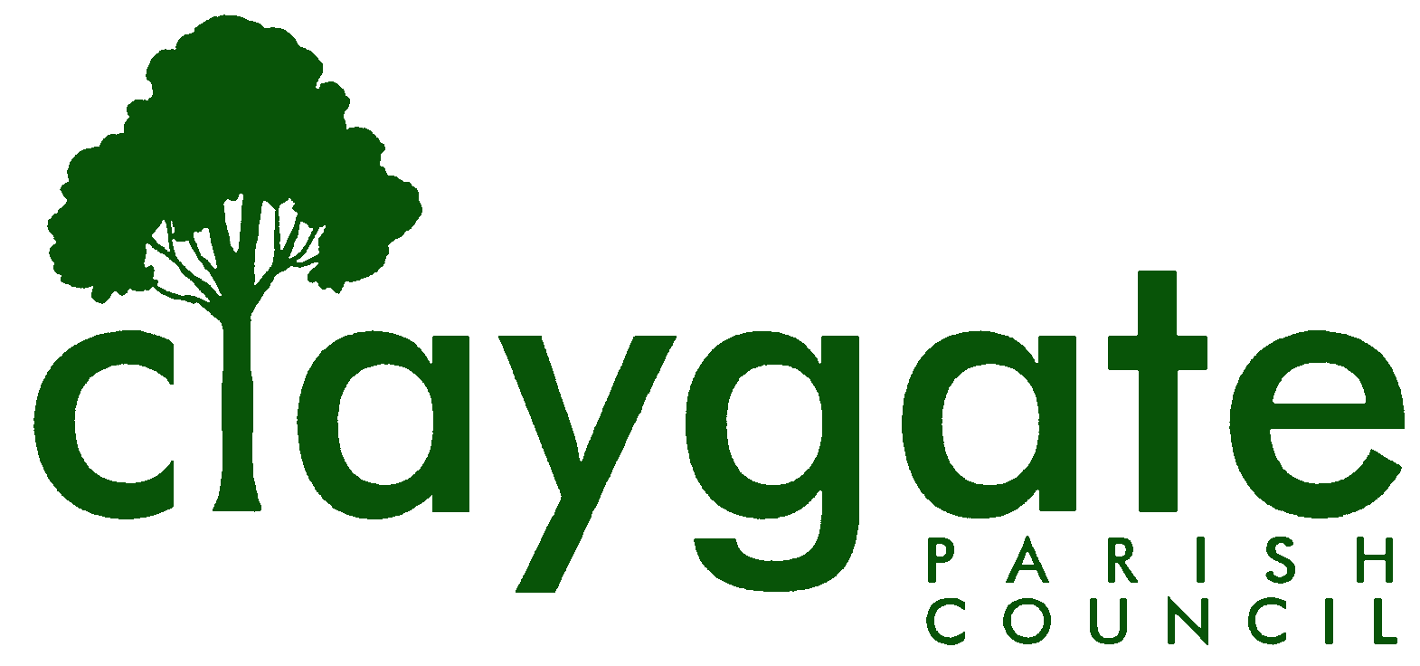

Equality and Diversity Policy

Contents
1. Introduction
2. Policy
3. Commitment to Equality and Diversity
4. Scope of The Policy
5. Objectives of The Policy
6. Equality Aims
7. Employment
8. Review

- INTRODUCTION

The Equality Act 2010 came into force in October 2010. The legislation covers a prescribed set of protected characteristics including age, disability gender reassignment, marriage and civil partnership, pregnancy and maternity, race, religion or belief, sex and sexual orientation.

It also covers prohibited conduct including discrimination, adjustments for disabled persons, victimisation and harassment; services and public functions; premises; employment; contracts; and, advancement of equality. The latter provision specifies a public-sector equality duty, which applies equally to town and parish councils.

- POLICY

The Parish Council is committed to promoting equality and diversity, providing an inclusive and supportive environment for all. In the implementation of this policy the Parish Council will:

• ensure that people are treated solely on the basis of their abilities and potential, regardless of race, colour, nationality, ethnic origin, religious or political belief or affiliation, age, gender, gender reassignment, marital status, sexual orientation, disability, socio-economic background, or any other inappropriate distinction;
• promote diversity and equality and value the contributions made by individuals and groups of people from diverse cultural, ethnic, socio-economic and distinctive backgrounds
• challenge inequality and less favourable treatment wherever practicable
• promote greater participation of under-represented groups by encouraging positive action to address inequality, promote an environment free of harassment and bullying on any grounds in relation to all staff, Councillors, contractors and visitors attending the Council’s offices or meetings.

The task of promoting social inclusion, tackling discrimination and encouraging equal opportunities are key issues for Claygate Parish Council and the Council is committed to:

• eliminating unlawful discrimination, harassment and victimisation;
• advancing equality of opportunity between different groups;
• fostering good relations between different groups

- COMMITMENT TO EQUALITY AND DIVERSITY

The Parish Council is committed to Equality and Diversity and to the vision of improving the quality of life for local people.

The Parish Council aims to be:
• Accessible
• Accountable
• Fair
• Inclusive
• Proactive
• Professional
• Responsible
• Transparent

Claygate Parish Council is committed to achieving equality of opportunity and valuing diversity in all aspects of its work:

- Through the delivery of our services to the community by ensuring that within reason, these services are accessible to all and that we fully recognise the diversity of people’s needs;
- b) In the Council Council’s leadership role, working with partners to promote the importance of treating every individual with dignity and respect.

- SCOPE OF THE POLICY

This policy is designed to value diversity and to ensure equality of opportunity and access to services and that no one receives less favourable treatment on the grounds of:

• Race (i.e. colour, ethnic or national origin, nationality or citizenship).
• Gender reassignment
• Disability
• Sex
• Sexual orientation
• Age
• Religion or belief
• Caring for others
• Trade Union or political activities
• Pregnancy and Maternity
• Marriage and Civil Partnership

This list is not exhaustive.

- OBJECTIVES OF THE POLICY

  - To improve delivery, information and access to services we will:

• Ensure all employees, contractors and users of our services are informed about our Equality and Diversity Policy;
• Apply equal opportunities principles to work undertaken for the council by external contractors, other organisations in receipt of council funding and in work with our partners;
• Rectify any elements of our work which have the potential for discrimination and prejudice.

  - To promote equality and diversity with other partners we will:

• Promote tolerance and respect between diverse groups and individuals;
• Acknowledge and celebrate, wherever possible, the variety of lifestyles and cultures within the Council
• Challenge all forms of discrimination within the Parish Council and the wider community;
• Support the development of these communities and assist them in challenging discrimination, harassment, bullying and violence.
5.3Responsibility and Liability All members of staff and Councillors remain personally
responsible for ensuring that they act within the law. The Council’s Executive Officer is responsible for ensuring that staff perform their duties in lawful manner and that proper training and support is provided accordingly. In certain circumstances the Parish Council could be vicariously liable for actions carried out by staff purportedly in the Parish Council’s name. Any member of staff or Councillor may be 5 HPC Equality & Diversity Policy July 2018/Readopted May 2019 personally liable if, whilst on Council business and despite guidance and training from the Council, they behave illegally in respect of the Equality Act 2010.
- EQUALITY AIMS

The Parish Council:

6.1 Age - shall not permit unlawful age discrimination.
6.2 Sexual Orientation - shall not permit unlawful discrimination.
6.3 Disability - will remove barriers to participation by disabled people, wherever possible.
6.4 Race/Ethnic Origin - will encourage participation of minority ethnic groups in its activities.
6.5 Religion - respects people from diverse religious and cultural backgrounds and will give due regard to the needs and requirements of people who adhere to a range of cultural and religious beliefs.
7. EMPLOYMENT
Claygate Parish Council is an equal opportunity employer and is committed to ensuring within the framework of the law that the Council’s workplaces are free from unlawful or unfair discrimination. Further information on the Councils policy in respect of employment can be found in the Equal Opportunities Policy contained in the staff handbook.
- REVIEW
Review of this policy will be carried out annually by Claygate Parish Council.

