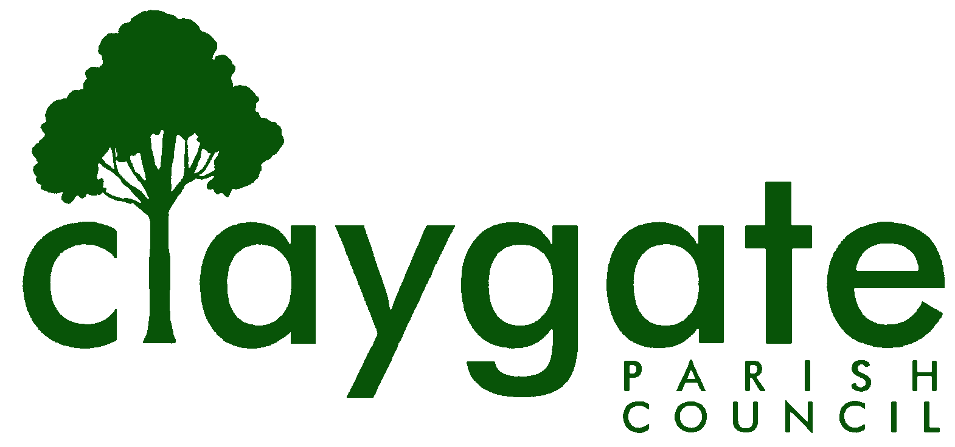

Dawn Lacey Clerk & RFO

Claygate Parish Council

Claygate Village Hall

Church Road

caring for Claygate Village Claygate

Surrey, KT10 0JP

Tel: 07741848719

Email: clerk@claygateparishcouncil.gov.uk
Website: www.claygateparishcouncil.co.uk
FINAL
10th August 2024

YOU ARE HEREBY SUMMONED TO ATTEND

A meeting of the Claygate Parish Council will be held on Thursday 15th August 2024
at 8.30pm Claygate Village Hall, Main Hall, Church Road

The meeting is open to the public and press. A quarter of an hour has been reserved for members of the public to address the Council, for three minutes each, on any subject relevant to the agenda. In order to address the meeting, we would appreciate you contacting the Parish Clerk before 11am on the day of the meeting who will allocate a slot. All meetings will operate to our Privacy Policy which can be found at www.claygateparishcouncil.gov.uk. Please note that the capacity of the hall is limited, and places will be allocated on a first come first served basis. Doors will open at 7.20pm.

Covid 19

If attendees have any of the main symptoms of Covid-19 and/or have tested positive to Covid prior to the meeting, you should not attend. Please refer to www.gov.uk for full guidelines.

Dawn Lacey
Clerk & Responsible Financial Officer

AGENDA

- To accept apologies for absence.

- To receive Declarations of Interest in items on the agenda.

- To confirm the minutes of the Parish Council Meeting held on Thursday 18th July 2024

- Review actioning of items from previous minutes and agree any further action required
(Actions List – Appendix 1)

- To answer any questions from the general public

- To Receive a Report of EBC’s Oversight & Scrutiny Committee & Agree Action As Appropriate

- To Receive a Report of EBC Audit’s and Standards

- To Receive a Report from the Planning Committee

- To Receive a Report from the E H & T Committee

- To Review the minutes from the recent EBC meeting held on 16th July 2024 (Appendix 2)

- In respect of the recommendations of Claygate The Way Forward (CTWF), from the meeting held on Thursday 18th July and to follow up on the following area:

To agree to defer until the following meeting discussion of the possibility of a new ‘This is Claygate’ website.

ACTION – Cllr Bingham

- Having regard to the resolution of the Council on 18 July 2024, to appoint pursuant to Standing Order 4 five Advisory Committees to take forward the recommendations of the Claygate Village Association in its report of 18 June 2024 “Claygate: The Way Forward”, as follows:

- a New Development and Housing Advisory Committee, to report to the Planning Committee;

- a Health, Wellbeing and Leisure Advisory Committee, to report to the Council;

- a Shops and Businesses Advisory Committee, to report to the Council;

- a Transport and Parking Advisory Committee, to report to the Environment, Highways and Transport Committee;

- an Environment and Sustainability Advisory Committee, to report to the Environment, Highways and Transport Committee.

- If the resolution in agenda item 12 is agreed, to appoint to the Advisory Committees set up under that resolution the following members:

- to the New Development and Housing Advisory Committee, Clive Thompson,

- to the Health, Wellbeing and Leisure Advisory Committee, John Bamford, Cllr Collon, Cllr French, Pam Jarvis and Chris Kerr

- to the Shops and Businesses Advisory Committee, Simon Baile, Philip Chapman, Emma Curtis, Cllr Holt, Ulrika Pulford, Gary State, Leo Tye, Nicole and Lauren Dodds, Redmond Walshe

- to the Transport and Parking Advisory Committee, Ben Full, Peter Robinson, Mark Sugden

- to the Environment and Sustainability Advisory Committee, Peter Stevenson

- to add further members to the above Committee’s to be authorised by the
Chairman Cllr Holt

- To Review and Approve draft Documentation for SCC application for a new bench on the Parade sponsored by the CPC and agree the way forward in principle (Appendix 3 and 4)

- To discuss any updates on arrangements of Remembrance Sunday on November 10th

- To update on the requested Tree Surgery Work on the Meadow Road Village Green

- To consider the Government Consultation on Amendments to the National Planning Policy Framework (NPPF) (Appendix 5)

- To agree any changes to the AGAR following audit feedback

- Matters for information purposes only

- To discuss the Way Maker Project at Holy Trinity Church – to discuss arrangements for attendance of PC representatives the meetings on Tuesday 10th September at 8pm or Wednesday 11th September at 10am (Appendix 6)

- To confirm the date and time of the next meeting which will be held on Thursday 12th September at Treetops Pavillion, Recreation Ground, Church Road

MEETING: Claygate Parish Council
VENUE: Claygate Village Hall, Main Hall, Church Road
DATE: Thursday 15th August 2024
TIME: 8.30pm

APPENDICES

APPENDIX 1 Actions from previous meeting held on Thursday 18th July 2024

APPENDIX 2a CPC meeting with EBC with no changes made

APPENDIX 2b CPC meeting with EBC including changes made

APPENDIX 3 Draft Initial Application for a Bench on the Parade

APPENDIX 4 Draft Application of a License for a Bench on the Parade

APPENDIX 5 National Planning Policy Framework (NPPF) from Cllr Collon

APPENDIX 6 Information regarding the Way Maker Project with Holy Trinity Church

