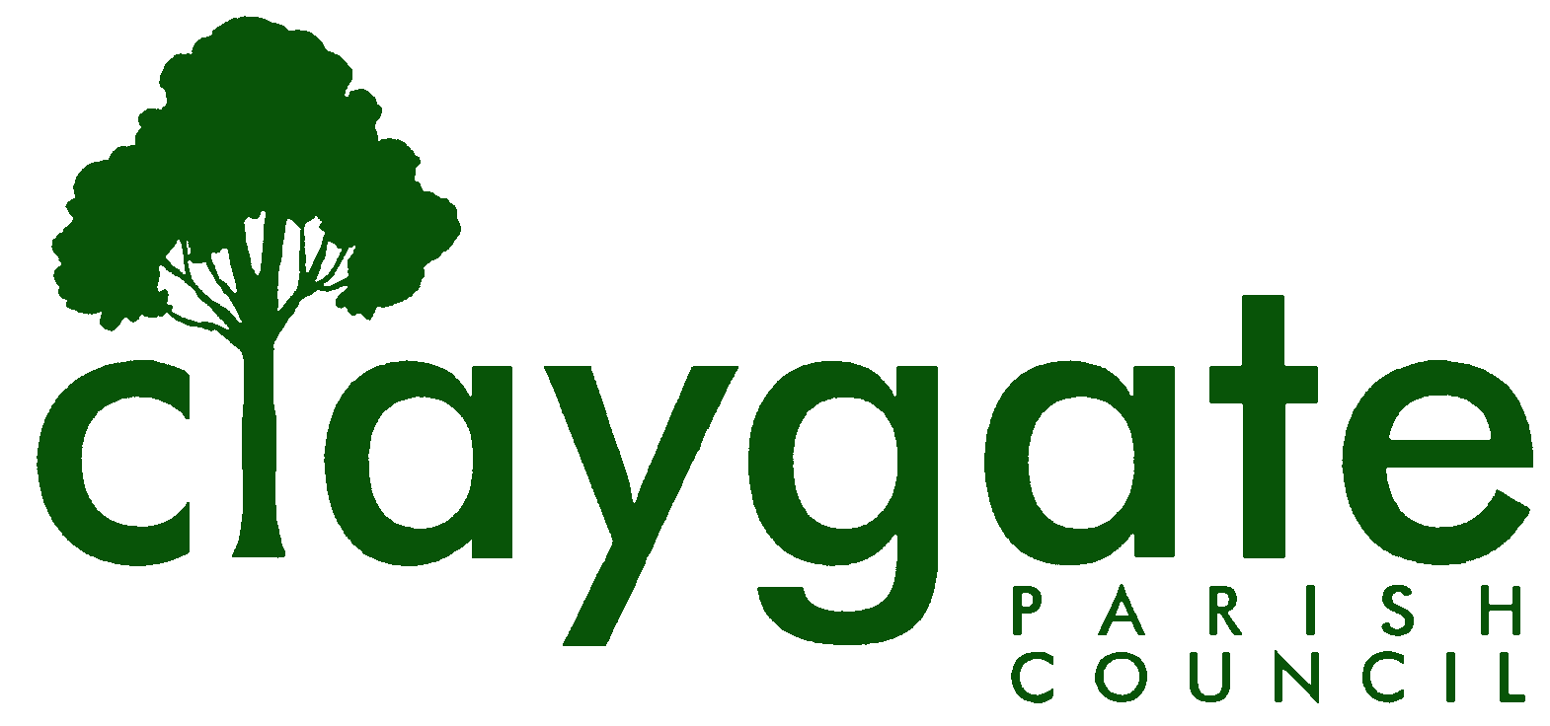

Dawn Lacey Clerk & RFO

Claygate Parish Council

Claygate Village Hall

Church Road

caring for Claygate Village Claygate

Surrey, KT10 0JP

Tel: 07741848719

Email: clerk@claygateparishcouncil.gov.uk
Website: www.claygateparishcouncil.co.uk
FINAL
2nd October 2024

YOU ARE HEREBY SUMMONED TO ATTEND

A meeting of the Claygate Parish Council will be held on Thursday 10th October 2024 at 8.30pm Treetops Pavilion, Recreation Ground, Church Road

The meeting is open to the public and press. A quarter of an hour has been reserved for members of the public to address the Council, for three minutes each, on any subject relevant to the agenda. In order to address the meeting, we would appreciate you contacting the Parish Clerk before 11am on the day of the meeting who will allocate a slot. All meetings will operate to our Privacy Policy which can be found at www.claygateparishcouncil.gov.uk. Please note that the capacity of the hall is limited, and places will be allocated on a first come first served basis. Doors will open at 7.20pm.

Covid 19

If attendees have any of the main symptoms of Covid-19 and/or have tested positive to Covid prior to the meeting, you should not attend. Please refer to www.gov.uk for full guidelines.

Dawn Lacey
Clerk & Responsible Financial Officer

AGENDA

- To accept apologies for absence.

- To receive Declarations of Interest in items on the agenda.

- To confirm the minutes of the Parish Council Meeting held on Thursday 12th September 2024

- Review actioning of items from previous minutes and agree any further action required
(Actions List – Appendix 1)

- To answer any questions from the general public

- To Receive a Report of EBC’s Oversight & Scrutiny Committee & Agree Action As Appropriate

- To Receive a Report of EBC Audit’s and Standards

- To Receive a Report from the Planning Committee

- To Receive a Report from the E H & T Committee

- Update from Claygate The Way Forward (CTWF), from the meeting held on 25th September

- To confirm arrangements for Remembrance Sunday on November 10th

- To update on the requested Tree Surgery Work on the Meadow Road Village Green

- To Discuss the Weeds and Kerbs and Pavements and to agree the next steps

- To receive details of grant applications and consider whether they will be approved

(Appendix 2)

- To report on finalisation of the external audit for 2023/2024

- To review the Quarterly financials and budget and sign off the reconciliation for September – to include the Reconciliations from April to Aug 2024

(Appendix 3)

- To consider and approve the costs of hiring HTC’s Hall and the provision of hospitality for expected attendees at the Green Network Elmbridge Event on Wednesday 20th November 2024

- To confirm the arrangements for agreeing the 2024/2025 budget for the Parish Council
(Appendix 4)

- To confirm arrangements for giving sight to the council of the Courier prior to publishing.

- To discuss whether it is possible to apply for a £1000 grant from the Elmbridge Community Fund towards the development of the ‘This is Claygate’ website

Matters for Information purposes only

a: Parish Council and This is Claygate Website – Cllr Holt to report on this at the Nov meeting

b: Update on the new bench on the parade – Cllr Holt to report on this at the Nov meeting

- To confirm the date and time of the next meeting which will be held on Thursday 7th November at Claygate Village Hall, Small Hall, Church Road

MEETING: Claygate Parish Council
VENUE: Treetops Pavilion, Recreation Ground, Church Road, Claygate
DATE: Thursday 10th October 2024
TIME: 8.30pm

APPENDICES:
Appendix 1: Review actions from previous meetings
Appendix 2: To discuss any Grant Applications
Appendix 3: To review the Quarterly Financials and Budgets
Appendix 4: To confirm arrangements for agreeing the 2024/2025 budget

