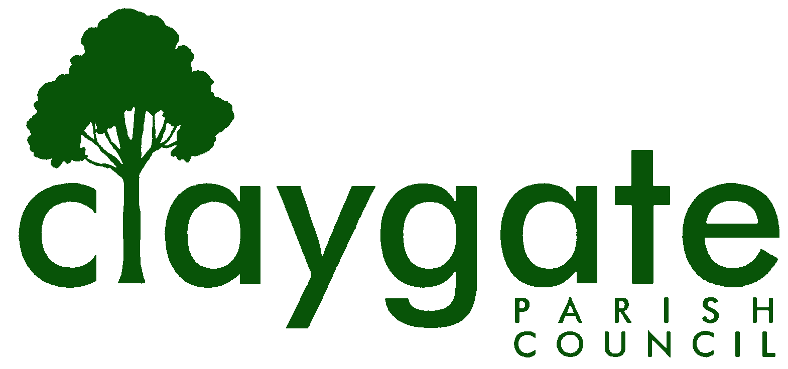
Dawn Lacey – Parish Clerk & RFO

Claygate Parish Council

Claygate Village Hall

Church Road

caring for Claygate Village Claygate

Surrey KT10 0JP

Tel: 07741848719

Email: clerk@claygateparishcouncil.gov.uk
Website: www.claygateparishcouncil.co.uk

DRAFT 14th January 2026

Minutes of the Planning Committee of Claygate Parish Council held on Thursday 8th January 2026, Claygate Village Hall, Small Hall, Church Road, Claygate

Present: Cllr Sheppard (Chair), Cllr Collon, Cllr Holt, Cllr Bingham,
Cllr Herbert, Cllr Burns and Cllr Ellis
In attendance: Dawn Lacey (Parish Clerk & RFO)
Non-Voting Advisor: John Bamford
Cllr Mike Rollings (EBC), Cllr French and 2 Members of the Public.

1. Apologies for absence.
Apologies from Non-Voting Advisor Vanessa Relleen.
2. Declarations of Interest on Items on the Agenda.

Cllr Ellis declared an interest in Item 11 – updates on the Raleigh Drive development. Cllr Sheppard declared that he was a resident of Raleigh Drive.
Cllr Collon declared an interest in Item 8 – Planning Application 7 Forge Drive.

3. To confirm the Minutes of the Meeting held on Thursday 11th December 2025.

The Minutes were agreed to be a correct record of the meeting and signed and dated by Cllr Sheppard.

4. To review actions from the previous meeting.

These had all been completed.

5. To answer any questions from members of the public.

There were no questions for the meeting.

6. To review any planning correspondence, notification of applications and outstanding results and agree any action required.

There was nothing to discuss.

7. To report on Applications Decided, and Appeals Lodged and Decided since last meeting and agree any action required.

Planning Application 2024/2548 illustrates the differences of judgement between CPC and EBC on their views. CPC objected to application 2024/2537 on grounds of overlooking, space standards and loss of light; EBC refused permission.

8. Discuss planning applications from Elmbridge Borough Council (EBC) Weekly Planning Lists (https://www.elmbridge.gov.uk/planning) for the following weeks and agree responses required: w/e 21st and 28th November and 5th December

See letters to EBC TPlan (Appendix 1).

9. To update on the Cloudy IT Systems and agree any action required.

Cllr Sheppard proposed that we postpone the application for a licence until April 2026 giving time for discussions with the Clerk. Meanwhile Cllr Sheppard will set up an account, using free credits, and upload EBC’s Planning Policies.

Proposed by Cllr Sheppard and seconded by Cllr Ellis – carried unanimously.

ACTION: Cllr Sheppard and Clerk

10. To discuss if there are any updates on the proposed Hook Park Development and agree any action required.

Cllr Sheppard confirmed he had given an interview with BBC Surrey and also lodged the CPC objections with EBC. Cllr Rollings informed the Committee that EBC have employed a Company to complete a Traffic Report. More information to follow.

11. To receive any updates on the Raleigh Drive Development and agree any action required.

2 residents of Raleigh Drive have written to EBC asking that S106 negotiations be halted until Thames Water can bring evidence to show that the sewer in Raleigh Drive can actually support the additional volumes from a new development, in the light of sewer overflows occurring since the installation of Hare Lane Green storm water tank. (Post meeting Note: Elmbridge have responded, saying that ,in the absence of a requirement from Thames Water for improvements to the sewer, they cannot impose a S106 obligation.)

12. To receive a report on EBC’s East Area Sub Committee Meeting and agree any action required.

Nothing to report.

13. To receive a report on EBC’s Planning Committee Meeting and agree any action required.

Currently nothing to report.

14. To discuss any Communication of Key Decisions to Residents and agree any action required.

15. To review any Compliance Issues in Claygate and agree any action required.

Nothing new to report.

16. To discuss any Licence Applications.

None.

17. Matters for information purposes only.

It was reported that the Government have￹￹￹￹￹￹￹￹￹￹￹ proposed revisions to the NPPF with the possibility of a presumption of development on Green Belt by Railway Stations. This item is to be added to the February agenda. Cllr Sheppard will collate comments from members and NVAs and circulate to Councillors. Councillors to read the draft comments and report any thoughts back to Cllr Sheppard. Cllr Collon will circulate some priority points that should be looked at, notably the section on Green Belt.

ACTION: Clerk
ACTION: Cllr Sheppard and Councillors
ACTION: Cllr Collon

18. Date of the next meeting 7.30pm Thursday 5th February 2026, Small Village Hall, Church Road, Claygate KT10 0JP.

MEETING: Claygate Parish Council, Planning Committee
VENUE: Claygate Village Hall, Small Hall, Church Road, Claygate
DATE: Thursday 8 January 2026
TIME: 7.30pm

Signed: Date:

