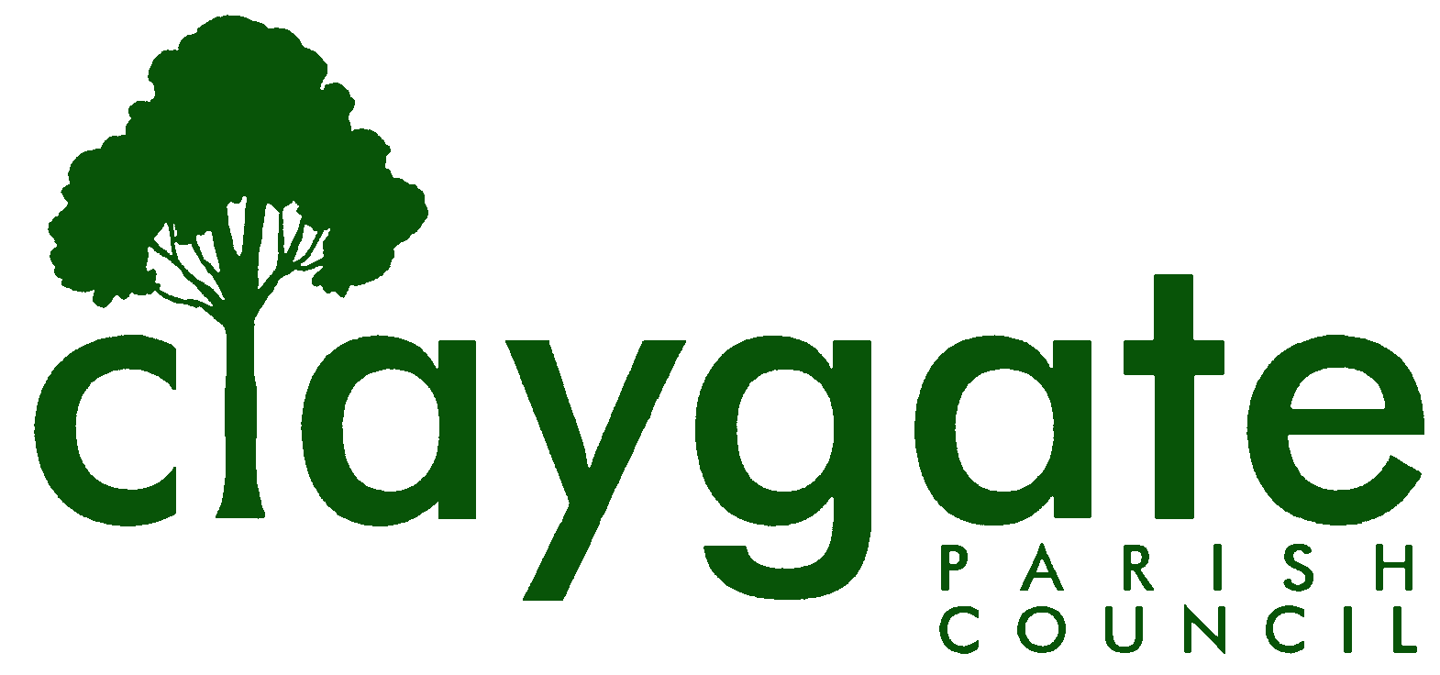
Dawn Lacey – Parish Clerk & RFO

Claygate Parish Council

Claygate Village Hall

Church Road

caring for Claygate Village Claygate

Surrey KT10 0JP

Tel: 07741848719

Email: clerk@claygateparishcouncil.gov.uk
Website: www.claygateparishcouncil.co.uk

DRAFT 17th March 2026

Minutes of the Planning Committee of Claygate Parish Council held on Thursday 5th March 2026 at 7.30pm at Claygate Village Hall, Small Hall, Church Road, Claygate

Present: Cllr Sheppard (Chair), Cllr Collon, Cllr Burns, Cllr Herbert and Cllr Ellis
In attendance: Dawn Lacey (Parish Clerk & RFO).
Non-Voting Advisors: John Bamford and Vanessa Relleen
SCCllr Andy Burton, Cllr French and 7 members of the Public.
1. Apologies for absence.
Apologies from Cllr Holt.
2. Declarations of Interest in items on the agenda.
Cllr Ellis and Cllr Sheppard are both Residents of Raleigh Drive and therefore declared an interest on Item 11 on the agenda. This item is to be brought forward in the meeting after Item 4 at which point Cllr Sheppard will leave the room and Vice-Chair Cllr Collon will take over the meeting.
3. To Confirm the minutes of the 5th February 2026 Planning Committee meeting.
These were agreed to be a correct account of the meeting and signed and dated by the Chairman Cllr Sheppard.
4. To review actions from the previous meeting.
These had all been completed.
5. To answer any questions from members of the Public.
Cllr Sheppard left the meeting at 7.35pm and Item 11 was brought forward as it is also in relation to this item.
Development North of Raleigh Drive - Elevated Risk to Existing Sewer System in Raleigh Drive.
The proposed development to the north of Raleigh Drive has significant implication for an existing infrastructure problem in Raleigh Drive. Investigations by residents have found that the existing “deemed” Foul Sewer is indeed a Combined sewer, which following significant storms extrudes pollutant water, and faeces, across the street up to & historically into resident’s houses.
Q. from a local resident: What is the Parish Council intending to do regarding the fact that the current infrastructure is not fit for purpose and indeed the problem will only be exacerbated with the proposed Raleigh Drive development.
It was proposed that a letter should be sent to the Chief Executive of Thames Water and copied to our MP, Ofwat and SCCllr Burton.
It was proposed that Cllr Burns would draft the letter and circulate to Councillors for approval.
Proposed by Cllr Collon and Seconded by Cllr Herbert – carried unanimously.
ACTION: Cllr Burns
Cllr Sheppard rejoined the meeting at 7.45pm.
6. Review planning correspondence, notification of applications and outstanding results and agree any action required.
An email had been received from a resident of Foley Road regarding an application from Claygate Primary School to Surrey Highways. Cllr Sheppard to contact the resident and NVA John Bamford to send the link regarding this application to Cllr Sheppard.
ACTION: NVA John Bamford and Cllr Sheppard
7. Review Report on Applications Decided, and Appeals Lodged and Decided since last meeting and agree any action required.

None

8. Discuss planning applications from Elmbridge Borough Council (EBC) Weekly Planning Lists (https://www.elmbridge.gov.uk/planning) for the following weeks and agree responses required: w/e 6th, 13th, 20th and 27th February 2026

See letters to EBC T-Plan (Appendix 1).

9. To discuss and confirm action on the draft NPPF consultation.
Cllr Collon had circulated his paper on the draft NPPF consultation to Councillors. Cllr Herbert had commented that it was an excellent piece of work. It was proposed that Cllr Collon submit the paper.
Proposed by Cllr Sheppard and seconded by Cllr Herbert – carried unanimously.
ACTION: Cllr Collon
10. To confirm and discuss if there are any updates on the proposed Hook Park Development and agree any action required.
At this stage there is nothing further to report. There is a meeting scheduled for the 18th March with the South Kingston Neighbourhood Group – Cllr Ellis to attend this meeting and report back to the next Planning Meeting in April.
ACTION: Cllr Ellis
11. To receive any updates on the Raleigh Drive Development and agree any action required.
This item was dealt with under Item 5 on the agenda.
12. Receive a report on EBC’s East Area Sub Committee Meeting and agree any action required.
Nothing new to report.
Next meeting scheduled for 20th April 2026.
13. Receive a report on EBC’s Planning Committee Meeting and agree any action required.
Nothing new to report.
Next meeting scheduled for 21st April 2026.
14. To review the progress on implementing GovAssist and agree any action required.
Cllr Sheppard reported that to continue further he would need to purchase 1000 credits at a cost of £30. This expenditure was agreed. Cllr Sheppard had asked some test questions and will continue to test. It is not possible to use the present set up to review a real Planning Applications, as the basic planning module will not take account of uploaded local policies. Cllr Burns to also take a look at GovAsst. Any other Councillors who wish to take a look should email Cllr Sheppard for the Password. It was agreed to add this to the April Planning agenda and also the April Main Meeting Agenda.
ACTION: Councillors and Clerk

15. Discuss any Communication of key decisions to Residents and agree any action required.

None.

16. To review any Compliance Issues in Claygate and agree any action required.

None.

17. To discuss any Licence Applications.

None.

18. Matters for information purposes only.

None.

19. Date of the next meeting 7.30pm Thursday 9th April 2026, Treetops Pavillion, Recreation Ground, Church Road, Claygate KT10 0JP.

MEETING: Claygate Parish Council, Planning Committee.

VENUE: Claygate Village Hall, Small Hall, Church Road, Claygate.

DATE: Thursday 5th March 2026.

TIME: 7.30pm

Signed: Date:

