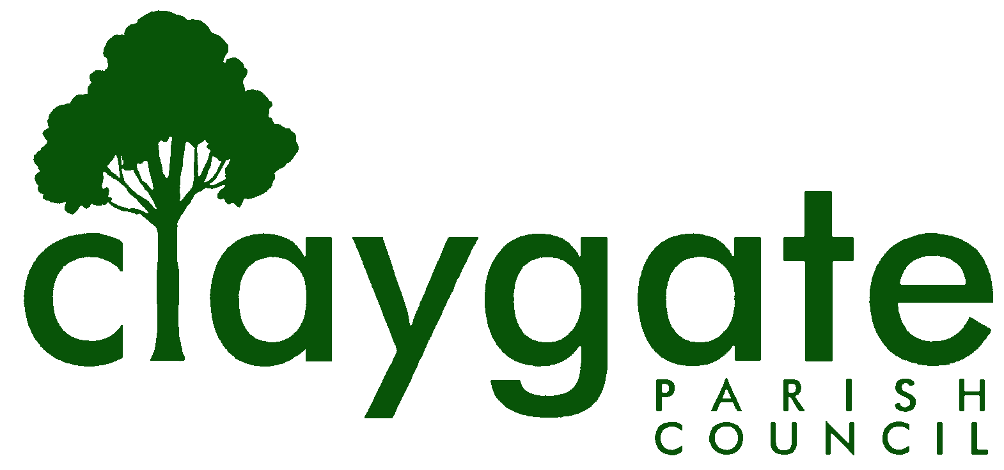
Dawn Lacey – Parish Clerk & RFO

Claygate Parish Council

Claygate Village Hall

Church Road

caring for Claygate Village Claygate

Surrey KT10 0JP

Tel: 07741848719

Email: clerk@claygateparishcouncil.gov.uk
Website: www.claygateparishcouncil.co.uk

FINAL 11th February 2026

Minutes of the Planning Committee of Claygate Parish Council held on Thursday 5th February 2025 at 7.30pm at Claygate Village Hall, Small Hall, Church Road, Claygate

Present: Cllr Sheppard (Chair), Cllr Collon, Cllr Holt, Cllr Burns, Cllr Herbert and Cllr Ellis
In attendance: Dawn Lacey (Parish Clerk & RFO).
Non-Voting Advisor: John Bamford.
Cllr French and 2 members of the Public.
1. Apologies for absence.
Apologies from Non-Voting Advisor Vanessa Relleen.
2. Declarations of Interest in items on the agenda.
Cllr Ellis and Cllr Sheppard are both Residents of Raleigh Drive and therefore declared an interest on Item 11 on the agenda.
3. To Confirm the minutes of the 8th January 2026 Planning Committee meeting.
These were agreed to be a correct account of the meeting and signed and dated by the Chairman Cllr Sheppard.
4. To review actions from the previous meeting.
These had all been completed. Re GovAssist, Cllr Sheppard reported that he had set up an account in the Clerk’s name, but discovered that only the Advanced Planning module, costing £495, could make use of uploaded local planning documents and that the Basic module appeared to be out of date on the NPPF.
Action: Cllr Sheppard to test the Basic Planning module further and invite comments from CloudyIT.
5. To answer any questions from members of the public.
There were no questions for the meeting.
6. To review any planning correspondence, notification of applications and outstanding results and agree any action required.
There was nothing to discuss.
7. To report on Applications Decided, and Appeals Lodged and Decided since last meeting and agree any action required.
It was noted that the appeal for 8 Langbourne Way (2025/1408) had allowed a technical breach of design guidelines, mainly because of similar extensions nearby.
8. Discuss planning applications from Elmbridge Borough Council (EBC) Weekly Planning Lists (https://www.elmbridge.gov.uk/planning) for the following weeks and agree responses required: w/e 9th, 16th, 23rd and 30th January 2026.
It was noted that the Applications for tree work had already been permitted.
Action: Clerk to clarify timescales for determining tree work applications with Elmbridge.
See letters to EBC TPlan (Appendix 1).
9. To discuss and confirm action on the draft NPPF consultation.
It was agreed that Cllr Sheppard would invite comments and additional responses from Councillors by 20th February to be sent to Cllr Collon and himself and then Cllr Collon would collate them ready for agreement at the next Planning Meeting being held on the 5th March 2026.
Proposed by Cllr Sheppard and seconded by Cllr Herbert. Carried unanimously.
Action: Cllr Sheppard and Cllr Collon.
Cllr Holt requested that a vote of thanks be recorded for all the hard work that the Councillors had put in on the NPPF.
Proposed by Cllr Holt and seconded by Cllr Herbert. Carried unanimously.
10. To confirm and discuss if there are any updates on the proposed Hook Park Development and agree any action required.
There is currently nothing new to report. CPC may be invited to attend the South Kingston neighbourhood meeting on 18 March.
11. To receive any updates on the Raleigh Drive Development and agree any action required.
Cllr Sheppard reported that it had become clear that Thames Water were unaware that the run off from the roof/gutters of the houses goes straight into the foul sewer and not the storm water drain. This calls into question the claimed ability of the existing foul sewer to support 60 extra houses, as it already occasionally floods after heavy rain.
It was also noted that the Rythe Bridge on Raleigh Drive appears to be in quite a bad state and needing some repairs. This will be discussed at the Environment, Highway and Transport meeting.
12. Receive a report on EBC’s East Area Sub Committee Meeting and agree any action required.
Nothing to report.
Next meeting scheduled for the 16th March 2026.
13. Receive a report on EBC’s Planning Committee Meeting and agree any action required.
Nothing to report.
Next meeting scheduled for the 10th March 2026.
14. To discuss Training opportunities and agree any action required.
Cllr Ellis and Cllr Burns to attend the Introduction to Planning for Town and Parish Councils on 15th April with SALC
ACTION: Clerk to book the course for them both.
15. Discuss any Communication of key decisions to Residents and agree any action required.
None.
16. To review any Compliance Issues in Claygate and agree any action required.
Cllr Holt confirmed that One Stop now switch off their illuminated lights at night. Also, that the Barbers have removed the front illuminated light to the back of the shop and switched the other one off at night.
17. To discuss any Licence Applications.
None.
18. Matters for information purposes only.
NVA John Bamford informed the meeting of the sad passing of Mrs Miller of Losely Farm. Mrs Miller was a former Councillor. The Council send their thoughts to her family at this time.
The BT site may be sold in 2030 and with the passing of Mrs Miller this could become an area vulnerable to development, if the proposed NPPF change to facilitate development of Green Belt near railway stations is implemented.

19. Date of the next meeting 7.30pm Thursday 5th March 2026, Small Village Hall, Church Road, Claygate KT10 0JP.
The meeting closed at 8.25pm
MEETING: Claygate Parish Council, Planning Committee.
VENUE: Claygate Village Hall, Small Hall, Church Road, Claygate
DATE: Thursday 5th February 2026
TIME: 7.30pm

Signed: Dated:

