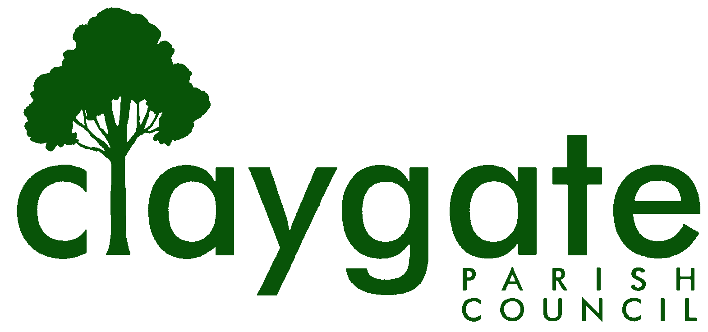

Kate Biggs

Clerk & Responsible Financial Officer

Claygate Parish Council

Claygate Village Hall

Church Road

caring for Claygate Village Claygate

Surrey, KT10 0JP

Tel: 07741848719

Email: clerk@claygateparishcouncil.gov.uk
Website: www.claygateparishcouncil.co.uk

26th September 2023

YOU ARE HEREBY SUMMONED TO ATTEND

An Extraordinary Meeting of Claygate Parish Council will be held on
Thursday 5th October at 7pm in the Small Hall, Claygate Village Hall

The meeting is open to the public and press. If attendees have any of the main symptoms of Covid-19 and/or have tested positive to Covid prior to the meeting, you should not attend. Please refer to www.gov.uk for full guidelines. A quarter of an hour has been reserved for members of the public to address the Council, for three minutes each, on any subject relevant to the agenda. In order to address the meeting, we would appreciate you contacting the Parish Clerk before 11am on the day of the meeting who will allocate a slot. All meetings will operate to our Privacy Policy which can be found at www.claygateparishcouncil.gov.uk.

Please note that the capacity of the hall is limited and places will be allocated on a first come first served basis. Doors will open at 6.50pm.

Kate Biggs
Kate Biggs
Clerk & Responsible Financial Officer

AGENDA

To accept Apologies for Absence.

To receive Declarations of Interest in items on the Agenda.

To confirm the minutes of the Claygate Parish Council (CPC) Extraordinary Meeting held on 7th September 2023.

To receive a report detailing the Torrington Lodge development discussion at the Elmbridge Borough Council extraordinary Cabinet meeting on the 27th September 2023 and agree actions.

5. To confirm that the next meeting of the Claygate Parish Council is to be held on Thursday 16th November at 7.30 pm at the Tree Tops Pavilion, Claygate.

MEETING: Claygate Parish Council Extraordinary Meeting
VENUE: Small Hall, Claygate Village Hall, Church Road, Claygate, Surrey KT10 0JP
DATE: Thursday 5th October 2023
TIME: 7.00pm

