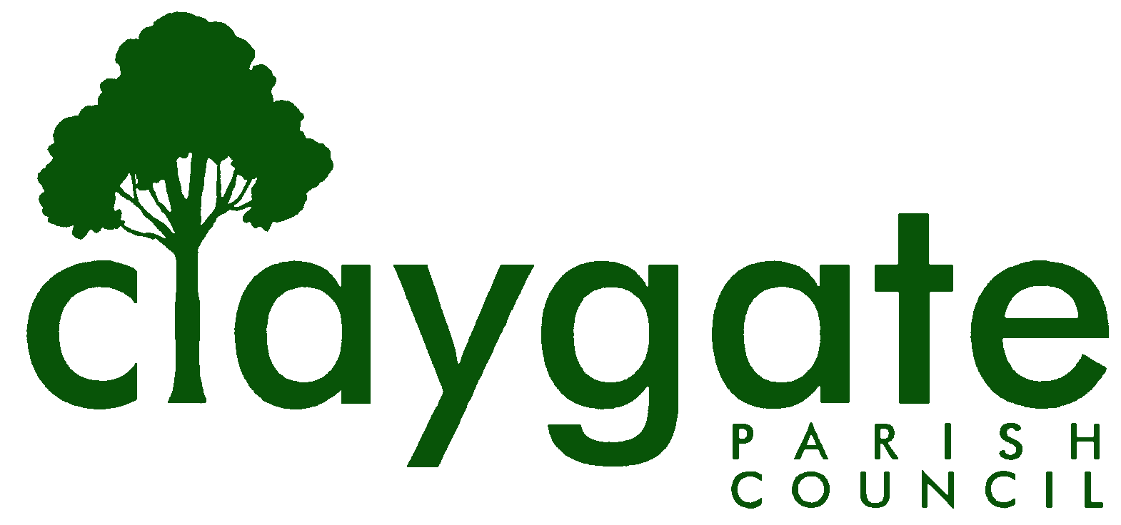
Dawn Lacey – Parish Clerk & RFO

Claygate Parish Council

Claygate Village Hall

Church Road

caring for Claygate Village Claygate

Surrey KT10 0JP

Tel: 07741848719

Email: clerk@claygateparishcouncil.gov.uk
Website: www.claygateparishcouncil.co.uk

DRAFT 29th October 2025

Minutes of the Environment, Highways and Transport Committee of Claygate Parish Council held on Thursday 23rd October 2025 at 8.30pm at Treetops Pavilion, Recreation Ground, Church Road, Claygate

Present: Cllr Bray (Chair), Cllr Holt, Cllr Moon, Cllr French, Cllr Burns and
Cllr Herbert
In attendance: Dawn Lacey (Parish Clerk & RFO)
Non-Voting Advisor: Vanessa Relleen
SCCllr Andy Burton, EBCllr Mike Rollings, Cllr Ellis and 1 Member of the Public
1. Apologies for absence.
Apologies from Non-Voting Advisor Mark Tymienicki
2. Declarations of Interest on Items on the Agenda.

None.

3. Election of Vice-Chairman.

Cllr Bray proposed Cllr Moon. This was seconded by Cllr French and carried unanimously.

4. Appointment of Non-Voting Advisors.

Cllr Bray proposed Simon Hope as an NVA for the Transport and Parking Group. This was seconded by Cllr Moon and carried unanimously.

Unfortunately, at this stage there is no one willing to stand for the Environment and Sustainability Group as an NVA.

Cllr Bray noted that this group will need special consideration when all Advisory Groups are reviewed in November’s Parish Council meeting. This was seconded by Cllr Holt and carried unanimously.

5. To confirm the minutes of the meeting held on Thursday 28th August 2025.

Both Cllr Moon and Cllr Burns abstained from voting as they were absent from this meeting.

Cllr Bray proposed, and Cllr Holt seconded, that the minutes be approved and this was agreed by Cllrs French and Herbert.

6. To report on the actions from the previous meeting. (Appendix 1)

Item 20 – to be discussed later in this meeting
All other Items have been completed.

7. To discuss any recent Correspondence received and Agree any Appropriate Action.

Cllr Bray reported on all Correspondence since the last EHTC meeting in August and his report is attached (Appendix 2)

There was a second complaint regarding rats in the Brash Pile. Bill Raspin had reported to Cllr Bray that it would cost £270.00 + VAT to bait the burrow. It was agreed to contact the Warden at the Firs before we look at this route to ask if they could speak to their residents about not putting food out.

This was proposed by Cllr Bray and seconded by Cllr Moon – carried unanimously

ACTION – Cllr Bray

It was also proposed that we add something to our Social Media and put something into our next Courier regarding the above.

Proposed by Cllr Moon and seconded by Cllr Burns – carried unanimously

ACTION – Cllr Moon and Clerk

Cllr Bray had had correspondence with Claygate Recreation Ground Trust re problems they have with ash die-back in trees around the Rec. Cllr Bray had sought advice from Cllr Collon as to whether such work could be funded by CIL and he had advised that it could. CRGT had been advised accordingly, so we await a CIL application from them. We will add this to the next Main meeting agenda in November

ACTION – Clerk

8. To receive a report from SCCllr Andy Burton

SCCllr Andy Burton kindly gave a full report which is attached (Appendix 2). He also confirmed that, if he was unable to attend a future meeting, he would send a report to the Clerk in advance of the meeting. (Appendix 3)

9. Update on the K3 Bus Route

Cllr Bray had written twice to our contact in First Bus but hadn’t heard back. Then today he received a call from our contact, who said that TfL seem to be reviewing many routes from a cost-cutting perspective. As such, he advised us not to get our hopes up as regards an extension of the K3 routes to the end of Coverts Road. The contact was due to meet TfL the following day which might be the last occasion when the idea could be floated.

10. To update on EBC’s Climate Change Citizens Panel.

Cllr French confirmed that there is currently nothing new to report. Their final meeting is due to be held on 10th November 2025 when their recommendations will be put forward. Cllr French will report back on this at the December meeting.

ACTION – Cllr French

11. To receive a report from Speed Watch

In the absence of Mark Tymieniecki, there was no verbal report. Mark had, however, send out the Surrey Roadsafe Monthly update prior to the meeting. Clerk to contact him to ask if it is ok to print and display this on our Notice boards and Website.

ACTION – Clerk

12. To receive a report from the Environment and Sustainability Group

Given that there is no NVA for this group, there was no report. Cllr Bray proposed that we remove this Standing Item from the agenda moving forward. This was seconded by Cllr Moon and carried unanimously.

ACTION – Clerk

13. To receive a report from the Transport and Working Group

Peter Robinson reported on behalf of Simon Hope and his full report is attached (Appendix 4)

There was a lengthy discussion about Peter’s wish to push further for more data from the CTWF survey to assist in preparing a balanced report on the issue of whether there should be a 20 mph zone on that stretch of Hare Lane from the railway bridge to The Swan. It was, finally, agreed that Cllr French would endeavour to arrange a meeting with Emma Curtis.

14. To update on the current situation regarding the Prioritisation of the Village Road Works.

After discussion, it was agreed that NVA Simon Hope would contact SCCllr Burton to discuss this in more detail and report back to the December meeting.

ACTION – Simon Hope

15. To Discuss the Material Available Under This Link - https://www.surreycc.gov.uk/roads-and-transport/roadworks-and-maintenance/roadworks/map - and Agree Appropriate Actions.

Cllr Moon will continue checking this link and will report anything relevant to the residents of Claygate onto our Social Media.

ACTION – Cllr Moon

16. To update on the situation with the Bench on the Parade

This was discussed and SCCllr Burton confirmed that he has lent his support to the idea and will report further in December.

17. To discuss the issues outside the Station, and other areas of the Village.

During the Clean Up Day it was noted that there appears to be drug taking in the Station Car Park as there were a lot of canisters dumped there. It was also noted that these are also being found in other areas of the Village.

It was proposed to contact SW Railways to see how often they clear the Car Park of rubbish. Transport and Parking to look into the illegal parking on the Parade area. Also, it was agreed to contact PC Ian Hallam regarding the Anti-Social Behaviour which is happening in the Village.

ACTION – Clerk

Cllr Bray read from an email he had had re the high kerb which stated that SWR have the project out to tender and that, once tenders are in, funding will be sought. This seemed to him to represent purposeful action.

18. To Discuss a Resident’s Request to Erect a Convex Mirror on The Firs Verge and Agree Appropriate Actions

SCCllr Andy Burton reported that Surrey County Council have said that it is against policy to install mirrors on Highways

19. To Discuss the Safety, or Otherwise, of the Asphalt Path Running Alongside the Firs Verge & Agree Appropriate Actions

SCCllr Andy Burton reported that an engineer from Surrey County Council will be visiting the site with a view to developing a method to make it safe.

20. To Consider the situation as regards Trees on the Meadow Road Island and Agree Appropriate Actions.

NVA Vanessa Relleen was asked if she would prepare a report and proposal for the work required on the trees.
This was proposed by Cllr Bray and seconded by Cllr Moon - carried unanimously. NVA Vanessa Relleen will report back at the next EHTC meeting

ACTION – NVA Vanessa Relleen

21. To discuss the Blue Heart Sites in the Village and Agree any Actions.

Bill Raspin had contacted Cllr Bray regarding a second tranche of Blue Heart Sites in Stevens Lane and Oaken Lane. As previously, Cllr Bray will write to confirm that the Parish Council support this.

Proposed by Cllr Bray and seconded by Cllr Moon – carried unanimously.

ACTION – Cllr Bray

22. Matters for Information Purposes

Cllr Moon reported that following the Clean Up Day one of the Banners had been stolen from Cavendish Drive and that a replacement banner needed to be purchased.

Proposed by Cllr Bray and seconded by Cllr Holt - carried unanimously

ACTION – Cllr Moon

23. To confirm the date of the next meeting which will be Thursday 11th December, Claygate Village Hall, Small Hall, Church Road, Claygate. KT10 0JP – 8.30pm

The meeting closed at 10pm

Signed: Date:

