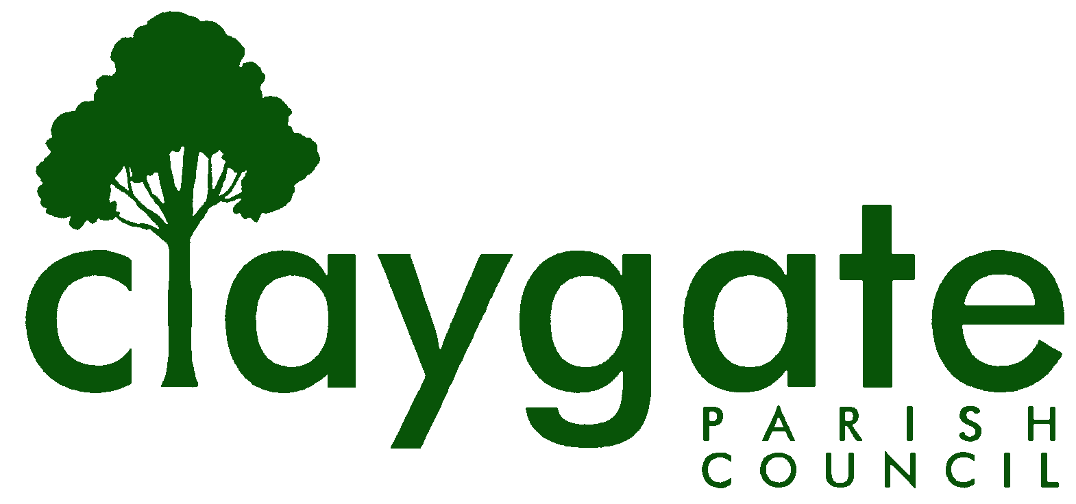
Dawn Lacey – Parish Clerk & RFO

Claygate Parish Council

Claygate Village Hall

Church Road

caring for Claygate Village Claygate

Surrey KT10 0JP

Tel: 07741848719

Email: clerk@claygateparishcouncil.gov.uk
Website: www.claygateparishcouncil.co.uk

DRAFT 16th December 2025

Minutes of the Environment, Highways and Transport Committee of Claygate Parish Council held on Thursday 11th December, Claygate Village Hall, Small Hall, Church Road, Claygate

Present: Cllr Bray (Chair), Cllr Moon, Cllr French and Cllr Herbert
In attendance: Dawn Lacey (Parish Clerk & RFO)
Non-Voting Advisor: Simon Hope
Cllr Ellis and 15 Members of the Public
1. Apologies for absence.
Apologies from Cllr Holt, SCCllr Andy Burton and Non-Voting Advisors Vanessa Relleen and Mark Tymienicki
2. Declarations of Interest on Items on the Agenda.

None

3. To confirm the minutes of the meeting held on Thursday 23rd October 2025.

These were agreed to be a correct account and were signed and dated by Cllr Bray.

4. To report on Actions from the Previous meeting (Appendix 1)

It was confirmed that they were all completed

5. To discuss any recent Correspondence received and Agree any Appropriate Action

Cllr Bray reported on all Correspondence since the last EHTC Meeting in October and his report is attached (Appendix 2)
Cllr Moon commended Cllr Bray for his transparency with all the Correspondence he receives and responds too.

6. To Receive a report from SCCllr Andy Burton

In the absence of SCCllr Burton, Cllr Bray read out his report, which had been received and circulated earlier in the day, and which is attached (Appendix 3). Cllr Bray noted the large number of items on which SCCllr Burton taken action on behalf of the village.

It was agreed that Cllr Bray would contact SCCllr Burton regarding the white lining at the junction of Common Road and Stevens Lane

ACTION: Cllr Bray

7. The K3 Bus Route – Update on Current Situation and Agree Appropriate Actions.

Nothing to report at this time.

8. To receive an update on EBC’s Climate Change Citizen’s Panel [CCCP] from Cllr French and Agree Appropriate Actions

Cllr French reported that the final meeting had taken place on the 19th November concluding the 6 scheduled sessions. There will be a written paper with a number of recommendations which will be presented to the Elmbridge Cabinet Meeting on the 4th February 2026. Once this has taken place we will know what the recommendations will be. Nothing further to do at this time.

9. To receive a report from Speed Watch – Mark Tymieniecki

The report from Mark had been circulated and will be added to the Website with the minutes from this meeting (Appendix 4). The general point was noted that the village seems not to have a significant problem with speeding.

ACTION: Clerk

10. To receive an Update from Transport & Parking Advisory Committee – with Specific Reference to The Commissioned Report on The Desirability, or Otherwise, of Creating a 20mph Limit at the Western End of Hare Lane.

Cllr Bray moved this item to the start of the meeting at 8.35pm for discussion.

He noted that 2 questions had been received from residents prior to the meeting and, while they were not directly related the Agenda Item above, he was happy that they be answered, verbally, in the meeting. He noted that the agenda was already very full and that, as a result, the meeting was not able to accommodate a whole debate on the matter, especially since this has been a matter for the full Council for some time.

The second question – put jointly by 4 residents - asked what the Committee’s response was to the fact that “100% of contactable properties” have now shown support for the creation of a 20mph zone at the east end of Hare Lane.

A general discussion was then held with the 4 Councillors who were present at the meeting.

It was agreed that something needed to be done but not necessarily 20mph. Cllr Burns had put together a paper on this, which is attached as Appx N.
The following points were made:
Enforcement may not be effective.
The narrowness of the pavement is a major factor.
The road is used all the time as it is one of the main entrance points in and out of Claygate. Therefore, it is all the residents in Claygate who should be allowed to have a view point on this matter.
The absence of a pavement on one side of the road affects 13 houses.
On the West End of the road they have moved back their hedge lines but the East End of the road haven’t.
This is a very tricky situation and one that needs to be dealt with correctly for all residents of Claygate. This Item will be ongoing in future meetings with any actions or updates needed.

Simon Hope also reported on various other things that the Transport and Parking Advisory Committee have been working on and his full report is attached. (Appendix 5)

Peter Robinson reported on his progress with the commissioned report, in particular that there was on-going difficulty with obtaining data he would like access to. Cllr French was hopeful that she might be able to help with this but, if not, Peter would have to manage without it.

11. To report any updates on Village Road Works and agree Appropriate Actions

Any updates can be seen in SCCllr Burton’s and Cllr Bray’s reports which are already in the minutes.

12. To update the residents on any Road Closures in Claygate

Cllr Moon noted that there is due to be a small set of roadworks behind The Firs.

13. To update on the Bench on the Parade

Cllr Bray confirmed that this has now been given permission. Wording for a plaque on the new bench will be discussed and agreed at Main Council on January 8th. To add this to the agenda for this meeting.

ACTION: Clerk

14. To update on any issues at the Station in Claygate.

Cllr Bray informed the Committee that Martyn Turner from SW Rail was waiting on budgets and approvals which will not be until Feb 26th 2026

15. Nul

16. To Discuss the Safety, or Otherwise of the Asphalt Path Running Alongside the Firs Verge & Agree Appropriate Actions

SCCllr Burton commented on this item in his report to confirm the SCC will be fixing the issues.

17. Update on the Trees on the Meadow Road Island and Agree Appropriate Actions.

NVA Vanessa Relleen had circulated 3 quotes for the work to be completed. The committee agreed to go with the Above All Tree Care quotation. This will be taken to Main Council in January for approval and be added to the agenda.

Proposed by Cllr Bray and seconded by Cllr Moon - carried unanimously

ACTION: Clerk

18. To discuss the recent developments with the Brash Pile and Agree Appropriate Actions.

There was a lengthy discussion, it was felt that the Brash Pile is a good thing to have for the environment but there is also concern about the rats, which have a burrow entrance about 3ft to the west of the pile. It was also reported that residents are still throwing food down on the ground even though they have been asked not to. It was also stated that the matter is creating some bad publicity for CPC.
It was proposed that [1] EBC Pest Control Dept be consulted for advice and [2] that another approach be made to The Firs [PA] management to try to get more action taken as regards food deposits.

This was proposed by Cllr Moon and seconded by Cllr Bray – carried unanimously

ACTION: Cllr Bray

19. To discuss the Wheelchair Access Issues – Torrington Cycle Barriers

In the absence of Cllr Holt who has been looking into this, it was agreed to defer this item until the February meeting.

ACTION: Clerk – to add to agenda

20. To receive an update on the Grit Bins and Agree Any Appropriate Actions.

Cllr Moon confirmed that he had been to the 3 grit bins in Claygate and informed the Committee that the hinges are buckled and rain water is getting into them. There is £750 for the Grit Bins on this year’s budget so Cllr Moon will look at costings for replacing one this year and then the other two in next year’s budget.

This was proposed by Cllr Moon and seconded by Cllr Herbert – carried unanimously

ACTION: Cllr Moon

21. Matters for Information Purposes only

SCC, via SALC, had sent a flyer round regarding a Flooding Toolkit, requesting that we post relevant parts to our social media and the Website

ACTION: Cllr Moon and Clerk

22. To confirm the date of the next meeting which will be Thursday 12th February, 2026, Treetops Pavilion, The Recreation Ground, Church Road, Claygate. – 7.30pm

There being no further business the meeting closed at 9.50pm

Signed: Date:

