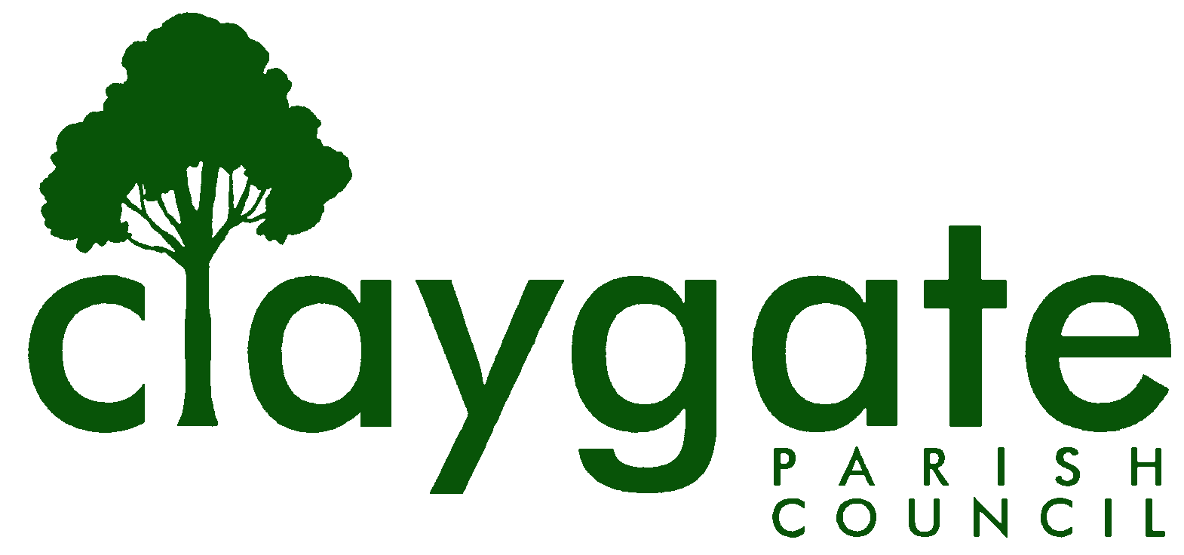

Dawn Lacey

Clerk & Responsible Financial Officer

Claygate Parish Council

Claygate Village Hall

Church Road

caring for Claygate Village Claygate

Surrey, KT10 0JP

Tel: 07741848719

Email: clerk@claygateparishcouncil.gov.uk
Website: www.claygateparishcouncil.co.uk

12th June 2024

Minutes of the CPC Environment, Highways and Transport Committee Meeting held on Thursday 6th June at 7.30pm at the Claygate Village Hall, Main Hall, Church Road, Claygate

Present: Chair of the Committee: Hadleigh Moon
Committee Members Council: Cllr Holt, Cllr Freeborn, Cllr French and Cllr Coffey
In attendance: SC Cllr Mark Sugden, Caroline Stevenson, plus 4 members of the Public

- Apologies for absence

Apologies for absence were received by Cllr Bray

- Declarations of Interest in items in the Agenda

None

- Election of Chairman

Councillor Bray was Proposed by Cllr Moon and this was seconded by Cllr Holt
Carried Unanimously

- Election of Vice-Chairman

Cllr Moon was Proposed by Cllr Holt and this was seconded by Cllr Coffey

Agreed by Cllr’s Freeborn, Cllr Coffey and Cllr French
Cllr Moon abstained

- Appointment of Co-Opted Committee Members

To appoint Mark Tymieniecki ACTION Cllr Holt to approach

To appoint Caroline Stevenson Proposed by Cllr Moon,
Seconded by Cllr Holt
Carried Unanimously

- To confirm the minutes of the previous Environment, Highways and Transportation Committee meeting held on 8th February 2024

One adjustment was made on Point 7 to Weight from Height
These were then signed and dated by Cllr Moon

- To report on the actioning of items from the previous minutes

Cllr Holt and tried to contact Sandra Cunningham at Claygate Primary School regarding a possible competition for a picture to be added to the Banners for Clean Up days but without success. It was agreed that Cllr Moon would add something to the social media pages offering this competition to all children in Claygate

ACTION Cllr Moon

- To answer any Questions from Members of the public

None

- To report any updates to the Council following discussions with Ian Burrows

Cllr Bray has requested to defer this to the next meeting being held on Thursday 1st August. It was discussed that Amey are trying to exit their Contract.
Caroline reported that the Potholes had been filled in by Red Lane

- To consider that CPC emails highways.volunteering@surrey.gov.uk to request to be registered as part of SCC’s Community Highways Volunteering Scheme

This was deferred to the next meeting being held on Thursday 1st August.
SC Cllr Mark Sugden informed the Committee that joining the group may enable them to do somethings they may not of been able to do before.

1: ACTION Clerk to speak to Cllr Bray regarding this
2: ACTION Cllr Bray to contact them about joining the SCC’s CHVS

To Register for this scheme was proposed by Cllr Moon and seconded by
Cllr Holt
Carried unanimously

SC Cllr Mark Sugden informed the Committee that there is now a map showing where all the grass cutting takes place.
3. ACTION Cllr Moon to look into this and contact Surrey Highways

- To report on charges at Claygate Train Station for parking

Cllr Holt informed the Committee that there is a £4 flat rate per day and an hourly rate. There is also a 20 minute grace period. Some residents have found the signage difficult as it is quite unclear.

SC Cllr Mark Sugden will send the SWR information to the Clerk
ACTION Cllr Moon will then contact SWR to see who the Contract is held by and find out about some possible better signage

- To discuss the maintenance of the Grit Bins

Clerk Dawn Lacey shared photos of the three grit bins and their current state with the rest of the Committee. It was discussed that the Claygate Parish Council give these back to Surrey County Council. In the meantime to find out where the Salt comes from.

1: ACTION Clerk to contact Sally at SALC regarding the Salt
2: ACTION Clerk to contact SCC regarding returning the Grit bins to
them
3: ACTION Cllr Moon to clean out the Grit bin by Station Road

- To confirm arrangements for the next community litter pick being held in October and discuss the possibility of a small prize for the largest bag of litter picked by the Scouts.

The next litter pick will be held on Saturday 5th October at 10am
Cllr Holt informed the Committee that the Scouts were a YES to help but unfortunately the Hub were unable to participate this time. Cllr Holt is still waiting to hear from the Guides and Brownies

ACTION Cllr Holt to organise a small prize for the biggest bag of litter
collected

- To hear a report from Speed Watch

This was agreed to be deferred until the next meeting

ACTION Clerk to contact Mark Tymieniecki regarding a report for the next meeting

- To discuss the suggestion of a crossing on Church Road

SC Cllr Mark Sugden requested to defer this to the next meeting being held on Thursday 1st August – Agreed

- How we can work with the CVA Environment Group

Caroline spoke on behalf of her husband Peter. She spoke about how much Goodwill there is in the Village at the moment.

The current CVA committee want to make many improvements in the Village and asked about the possibility of grants from the Parish Council.

There were talks regarding the empty land on Coverts Road where these could possibly be adopted and then if required be handed back to the Crown Estate as and when requested.

There are lots of members on the CVA group who take on regular litter picks to keep the Village looking clean and tidy.

They are looking to maybe become a Co-Ordinating group to the CPC where they could be a sounding board for various ideas.

The CVA are going to meet up some more and then come back to the CPC with some ideas and strategies.

The Clerk suggested that maybe one of the CVA committee be co-opted onto the CPC EHTC Committee – this to be discussed further at future meetings

- To review the Young Advisors Ideas

The suggestion of a prize at the next Litter Pick – this was discussed under Item 13 and is being carried out by Cllr Holt

- Matters for information purposes only

There is a Processionary Moths Nest in Foxwarren and this has been reported to David Page at EBC.

A speed survey was discussed to find out how much traffic travels down Woodstock Lane and through Claygate from Hook. To see what has happened to all the HGV traffic and the potential development of access roads both on and off the A3 and if we can reduce this. Something to be discussed in more detail at future meetings.

To look at the costs of putting in a further bench on the Claygate Parade with a higher seat and multiple arms.

ACTION: Cllr Holt

- To discuss the possibility of Trough sponsors for Highway Garden Sites from Schools and Nurseries in Claygate

This was an idea from our Young Advisor to see if the local Schools and Nurseries could perhaps in some way help to maintain these.

ACTION Cllr Holt to contact the local schools and nurseries about this idea

- To discuss the issues in Holroyd Road and if we can help with any action

The Clerk had received an email from a Holroyd Resident with deep concerns about the state of the garages in the Holroyd Road. There is currently quite a lot of fly tipping which is causing the presence of Rats and vermin. This was discussed in detail and agreed that this is a Public Health matter. The Parish Council are to write to the Health Team at SCC and also to PA Housing who own the site. In the meantime, to get some photo evidence of the area in question

1: ACTION Cllr Moon and Cllr Coffey to go and take photographs
2: ACTION Cllr Moon to draft a letter to EBC and PA Housing and pass
to the Clerk to forward to the correct departments

- Date of next meeting 7.30pm, Thursday 1st August in the Main Hall, Claygate Village Hall, Church Road, Claygate

MEETING: CPC Environment, Highways and Transport Committee
VENUE: Main Hall, Village Hall, Church Road, Claygate, KT10 0LJ
DATE: Thursday 1st August 2024
TIME: 7.30pm

Signed: Date:

