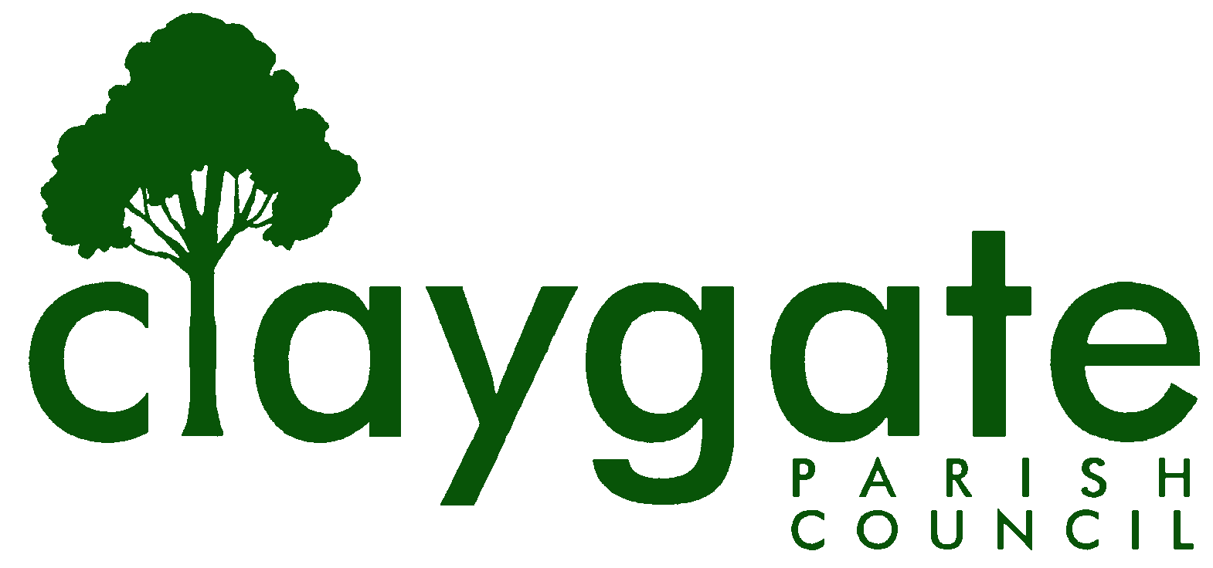
Dawn Lacey – Parish Clerk & RFO

Claygate Parish Council

Claygate Village Hall

Church Road

caring for Claygate Village Claygate

Surrey KT10 0JP

Tel: 07741848719

Email: clerk@claygateparishcouncil.gov.uk
Website: www.claygateparishcouncil.co.uk

FINAL 26th February 2026

YOU ARE HEREBY SUMMONED TO ATTEND

A Meeting of the Planning Committee of Claygate Parish Council will be held on Thursday 5th March 2026 at 7.30pm at Claygate Village Hall, Small Hall, Church Road

The meeting is open to the public and press. A quarter of an hour has been reserved for members of the public to address the Council, for three minutes each, on any subject relevant to the agenda. In order to address the meeting, we would appreciate you contacting the Parish Clerk before 11am on the day of the meeting who will allocate a slot. All meetings will operate to our Privacy Policy which can be found at www.claygateparishcouncil.gov.uk. Doors will open at 7.20pm.

Dawn Lacey
Clerk and RFO

AGENDA

1. Apologies for absence.
2. Declarations of Interest in items on the agenda.
3. Confirm the minutes of the 5th February 2026 Planning Committee meeting.
4. Review actioning of items from previous minutes and agree any further action required. (Appendix 1)
5. To answer any questions from members of the public.
6. Review planning correspondence, notification of applications and outstanding results and agree any action required.
7. Review Report on Applications Decided, and Appeals Lodged and Decided since last meeting and agree any action required. (Appendix 2)
8. Discuss planning applications from Elmbridge Borough Council (EBC) Weekly Planning Lists (https://www.elmbridge.gov.uk/planning) for the following weeks and agree responses required: w/e 6th, 13th, 20th and 27th February 2026 (Appendix 3)
9. To confirm the draft response to the NPPF consultation, and agree any action required.
10. To confirm and discuss if there are any updates on the proposed Hook Park Development and agree any action required.
11. To receive any updates on the Raleigh Drive Development and agree any action required.
12. Receive a report on EBC’s East Area Sub Committee Meeting and agree any action required
13. Receive a report on EBC’s Planning Committee Meeting and agree any action required.
14. To review the progress on implementing GovAssist and agree any action required.
15. Discuss any Communication of key decisions to Residents and agree any action required.
16. To review any Compliance Issues in Claygate and agree any action required.
17. To discuss any Licence Applications.
18. Matters for information purposes only.
19. Date of the next meeting 7.30pm Thursday 9th April 2026, Treetops Pavillion, Recreation Ground, Church Road, Claygate KT10 0JP.

MEETING: Claygate Parish Council Planning Committee
VENUE: Claygate Village Hall, Small Hall, Church Road, Claygate, Surrey KT10 0JP
DATE: Thursday 5th March 2026
TIME: 7.30pm

APPENDICES

APPENDIX 1: Actions from the previous meeting

APPENDIX 2: Review Report on Applications Decided, and Appeals Lodged and Decided since last meeting and agree any action required.

APPENDIX 3: Discuss planning applications from Elmbridge Borough Council (EBC) Weekly Planning Lists (https://www.elmbridge.gov.uk/planning) for the following weeks and agree responses required

