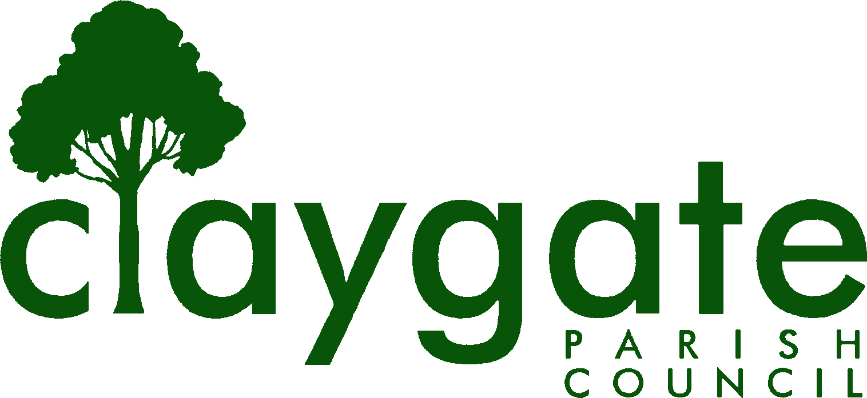
caring for Claygate Village
Claygate Parish Council CIL Funding Application
Form

15% of money received through the Community Infrastructure Levy, collected by Elmbridge Borough Council (EBC) from development in Claygate, is paid to Claygate Parish Council. Any CIL monies due are confirmed by EBC at the end of 6 month periods ending in March and September and paid to Claygate Parish Council shortly thereafter. The funds are available to spend on local projects in Claygate. As set out in the CIL Regulations, this local proportion of CIL should be used for:

- The provision, improvement, replacement, operation or maintenance of infrastructure; or
- Anything else that is concerned with addressing the demands that development places on an area

The definition of infrastructure is broad and includes amongst other items:

- Roads and other transport infrastructure
- Schools and other educational facilities
- Medical facilities
- Open spaces
- Sporting and recreational facilities
- Flood defences

Please read the Claygate Parish Council CIL funding application form guidance notes before completing this form. To discuss a potential project, or for further guidance, please contact the Parish Clerk at clerk@claygateparishcouncil.gov.uk on 01372 467000.

Please note that if an external organisation has been granted CIL funds for a project it may not apply for further CIL funding, regardless of the project, until twelve months have elapsed since the previous award was granted.

CIL applications will be considered at full meetings of Claygate Parish Council – there are 6 meetings per year and dates of meetings are available on the Claygate Parish Council website – www.claygateparishcouncil.gov.uk and on the noticeboards at the Village Hall, Church Road and Boots on Hare Lane.

Please return the completed application forms and supporting information to: clerk@claygateparishcouncil.gov.uk at least 2 weeks prior to a meeting of the full Claygate Parish Council

Claygate Parish Council CIL Funding Application Form

1. Applicant organisation | Claygate Village Hall Association (CVHA)
2. Name and position of main contact | A Woolhead Hall Manager

3. Applicant contact details (phone no, email and address) | 07917244751  tony.woolhead@ntlworld.com  Foley Cottage, 84 Foley Road,  Claygate  Surrey. KT10 0NB
4. Type of organisation  If a charity, please provide registration number | Charity  305007
5. Is the organisation able to reclaim VAT? | No
6. Location of project | Claygate Village Hall  Church Road,  Claygate,  Surrey.  KT10 0JP

- Summary of the project proposal
This project is the final part of a major initiative (CVHA Heating Strategy program) designed to improve our energy efficiency. We have over the last 2 - 3 years installed insulation throughout the Hall (the building dates back to the 1960's when insulation wasn't high on the building agenda) and have replaced our heating control systems with three Nest units which give us greater control over the use of the heating and also enables the capping of the maximum temperature for each Hall.
All three of our Warm Air Heating systems were identified as requiring urgent replacement.
One of these three Heating Systems suffered a breakdown during the Winter and had to be replaced due to there being no parts available to affect a repair. The two remaining Heating Systems are now 20+ years old, obsolete and also have no parts available should they suffer a breakdown. They are non-condensing and replacing with a condensing system has many advantages the most important of which are: Increased energy efficiency - our old systems do not reach over 55-65% efficiency whereas condensing systems can reach up to 90-99% efficiency. Lower carbon footprint - condensing systems can help lower our fuel bills significantly and reduce our carbon footprint potentially saving up to 1,200 kg of carbon a year Safer - here is no risk of contact with any toxic substances
We now need to urgently complete the project and replace the two remaining heating systems CIL Funding will be a major contributor to the cost of replacing the two heating systems with the rest of the funding being provided by CVHA.

- Estimated project cost
Estimated project cost is £15,600

Cost Summary breakdown

Main Hall Heating System Replacement - £8,800
Small Hall Heating System Replacement - £6,800

Note.
Warm air commercial Heating System suppliers are very few and far between
So unfortunately, we haven’t been able to furnish the 3 quotes normally required but have done some research to confirm that the Heating units being offered are as far as we can see at market prices.
CVHA has also been using Nordec for 20+ years (they installed the Heating systems we are now looking to replace) in which time we have formed a trusted relationship which we want to continue into the future.

Up to £500 – One Quote requested

£500 - £1500 – Two Quotes requested

£1500 +
Three quotes requested

- Please show in the table the amount of CIL funding being sought and any other contributions that may have been allocated for this scheme

 |  |  | Amount | Detail
 | CIL funding sought |  | £14,000
 | Any other Local authority contribution e.g. EBC and/or SCC
 | Third party contribution |  | £1,600 | CVHA
 | Total cost |  | £15,600
10. Detail of additional sources of funding available |  | CVHA Capital reserves
11. Why is CIL funding being sought? Please provide details of sources of funding already considered or applications made for funding |  | CVHA authorized a release of £10,400 from its Capital reserves for the replacement of all three Heating systems of which £8,800 was used in replacing the Foyer end Main Hall Heating system leaving £1,600 available to complete the project (i.e. replacement of Stage End Main Hall & Small Hall Heating systems).  Therefore, the remaining amount is being sought from CIL funding.  Several alternative sources of funding have been considered.
12. Please indicate whether the organisation has previously received CIL or other funding sources from either Claygate Parish Council and/or Elmbridge Borough Council. If yes, provide amounts and timings |  | CIL award of £13,500 in May 2020 from Claygate Parish Council - Upgrade of Village Hall Toilets  £1500 in May 2020 from Claygate Parish Council - Upgrade of Village Hall Toilets  Community Climate & Nature Grant £1,300 from Claygate Parish Council Feb 2023 for Installing Insulation  CIL award of £10,679 for Replacement of Curtains and Chairs Sept 2024
13. How does the project help address the demands of development in the area. What evidence is there to support this? |  | Throughout its history Claygate has not had a Council built or sponsored Community space. The Village Hall was built to fill this vacuum and was  constructed in the late 1950’s from private donations within the local community.  It is held in trust and as such wholly owned by the residents of Claygate and is administered on their behalf by a group of Trustees (these are drawn from the local community, and local organisations based at the Hall).  Since the Hall opened, it has provided an invaluable facility for the growth of key local activities across all age groups literally “from babies to the retired”.  Current users fall into a number of categories local societies for regular public meetings and committee meetings, (CDS, CVWI, Gardening Soc, U3A), we support local provision for childcare (pre-school) and health and fitness, (Yoga, Pilates, Line Dancing, Fitness classes), recreational activities for children that promote health and wellbeing (pre-school dance and football classes, after school performing arts classes). We have the largest capacity other than the church in Claygate and thus support Community events and meetings such as Get Involved Days, public meetings and charitable fundraisers such as quiz nights, as well as private events such as parties, wedding celebrations and funerals. Thus, Claygate Village Hall continues to provide a location for the various activities a growing and vibrant community demands (a look at the Hall’s diary for 2024 shows a very full calendar).  It receives no outside funding and as such is funded entirely from its lettings.  This project will make a major contribution to the improvement of an essential built community and major recreational space, extensively used for community events.
14. What evidence is there of support from the community |  | The Village Hall is in use daily from early morning to late in the evening.  It is one of the highest utilised in Surrey and there continues to be a substantial and sustained demand for the use of the Village Hall’s facilities from many and varied local organisations.  There is little doubt on the demand for the ongoing, viable usage of the Village Hall as is evidenced by the number/range of hirers.  The CVHA Board of Trustees has four Claygate based Community groups represented on it -  Claygate Dramatic Society  Claygate Village WI  Claygate Flower Show  Claygate Gardening Society  and all our Community Trustees are Claygate based.  All CVHA Trustees have expressed support for the proposed project.  Additionally, support has been received from the following hirers  Impact Dance  Claygate Dramatic Society
15. How does this project help mitigate climate change? |  | The final part of the Heating Strategy program will have a substantial impact in helping CVHA to reduce its fossil fuel consumption.  Installing condensing systems has many advantages the most important of which are:  Increased energy efficiency - our old systems do not reach over 55-65% efficiency whereas condensing systems can reach up to 90-99% efficiency.  Lower carbon footprint - condensing systems will help lower our fuel bills significantly and reduce our carbon footprint potentially saving up to 1,200 kg of carbon a year  Safer - here is no risk of contact with any toxic substances
16. Proposed timescales for the project |  | If funded the intention is to complete the project during April 2026
17. Is there a related revenue spend (i.e. day-to- day running costs) associated with the project? How will this be addressed? |  | No – day to day running costs will be funded from income.
18. If the organisation is not in the public sector, please provide details of the organisation’s finances  Please include a copy of the most recently audited accounts, including details of unrestricted reserves |  | All financial information is publicly available on the Charity Commission website, but a copy of the most recent accounts is attached.  A copy of the Halls Reserves Policy is attached.  A copy of the Halls Asset Management Plan is attached.
19. Do you need planning permission to carry out the works? |  | No
20. If planning permission is required is it in place to carry out the works?  If so, please provide the application number |  | N/A

Section E: Declaration

When you have completed the application, please sign this declaration and submit the application form as directed.

To the best of my knowledge the information I have provided on this application form is correct.

If Claygate Parish Council agrees to release funds for the specified project, these funds will be used exclusively for the purposes described. In such an event, I agree to inform Claygate Parish Council via the Parish Clerk of any material changes to the proposals set out above. When requested, I agree to provide Claygate Parish Council with all necessary information required for the purposes of reporting on the progress or otherwise of the identified project. I recognise the Parish Council’s statutory rights as the designated provider of these CIL funds, which includes provisions to reclaim unspent or misappropriated funds.

Privacy Notice: By signing this form, the applicant agrees to Claygate Parish Council checking all supplied information for the purposes of informing decision making. The information on this form will be stored in the Parish Council’s filing system and summarised in the Council’s accounting system for the sole purpose of fund processing, analysis and accounting. Information about the project may be publicised on Claygate Parish Council’s website and in public material for publicity purposes. Personal data will not be disclosed without any prior agreement of those concerned, unless required by law. For further information on the Council’s privacy policy, please see:
www.claygateparishcouncil.gov.uk. Statutory Information, then Privacy Policy.

Signed: A Woolhead

Organisation: Claygate Village Hall Association

Date: 26/02/2026

All organisations involved with the application will need to sign and date the form. Signed:
Organisation:

Date:

Adopted March 2021

