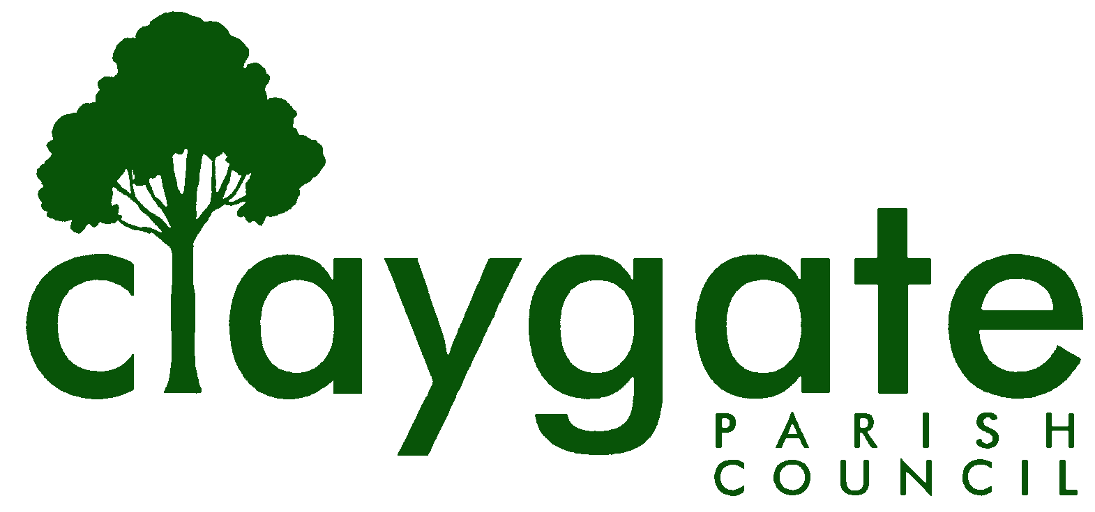

Dawn Lacey Clerk & RFO

Claygate Parish Council

Claygate Village Hall

Church Road

caring for Claygate Village Claygate

Surrey, KT10 0JP

Tel: 07741848719

Email: clerk@claygateparishcouncil.gov.uk
Website: www.claygateparishcouncil.co.uk

9th January 2026
Andrew Cooper,
Head of Finance,
Elmbridge Borough Council,
Civic Centre,
High Street,
Esher,
Surrey,
KT10 9SD
RE CLAYGATE PARISH COUNCIL: PRECEPT 2026/2027
Dear Andrew,

Further to Colin McKay’s letter on the 5th December 2025, the agreed tax base for Claygate Parish Council for 2026/7 is 3,601. I can confirm that at the Parish Council meeting on the 8 January 2026 it was agreed that the Council levy a precept of £59,957 for the financial year 2026/2027 with a 3% increase for the financial year 2026/27 raising the Band D rate from £16.17 to £16.65

Yours sincerely

Dawn Lacey
Clerk & Responsible Financial Officer
cc: Cllr Holt, Chairman

